

JaDON

E-Project Report



**Group Member**

|  |  |  |
| --- | --- | --- |
| *S.No* | *Student ID* | *Student Name* |
|  |  |  |
| 1 | Student1155635 | Fahad tariq |
| 2 | Student1157257 | Muhammad umar |

**Project Advisor**

Engr. Gulraiz Gulshan



**Aptech Computer Education**

Korangi Center

**ACKNOWLEDGEMENT**

First of all we would like to thank ALLAH the almighty who make us able to complete this project.

After that we would like to express profound gratitude to our internal project advisor, Center Faculty Head, ***Engr. Gulraeez Gulshan***, for his precious support, back-up, supervision and useful suggestions throughout this project. His moral support and continuous help enabled us to complete our work successfully. We are also highly thankful to the ***Center Management*** for their valuable suggestions, healthy analysis and support throughout this project.

We are grateful to the faculty members of Aptech Korangi Center who were always there to help us despite of their personal workload.

We are as ever, especially indebted to our parents for their love and support throughout our life. We also wish to thank our classmates, friends and all the individuals or groups that were involved in this project by any mean.

Gulraiz Gulshan

Contents

2 E-Project 5

2.1 Website Features 6

2.2 Site Requirement 6

3 E-Project Design 6

3.1 Sitemap 6

3.2 Website structure 8

3.2.1 Bootstrap Grid System 8

3.2.2 Home Page Layout 9

3.2.3 About page lay-out 10

3.2.4 Meals Page lay-out 11

3.2.5 Catering 12

3.2.6 Galery 13

3.2.7 Award 14

3.2.8 Countact us 15

3.2.9 Feedback 16

4 E-project snapshots 17

4.1 Home page snapshots 17

5 User guide 25

5.1 Home page layout. 25

5.2 About page layout. 26

5.3 Gallery page layout. 27

5.4 Contact us 28

5.5 FOOOTER 29

5.6 Meals 30

5.7 Catering 31

5.8 Award 32

6 References 33

7 Appendix I –Source code 33

7.1 Main style sheet 33

Table of Figures

Figure 1 6

Figure 2-SITEMAP---Figure 3 HOME 8

Figure 4 ABOUT 11

Figure 5 MEAL 12

Figure 6 CATERING 13

Figure 7GALLERY 14

Figure 8AWARD 15

Figure 9 CONTACT 16

Figure 10 FEEDBACK 17

Figure 11 home page snapshot 18

Figure 12 about page snapshot 19

Figure 13 MEALS snapshot 20

Figure 14 CATERING page snapshot 21

Figure 15 GALERY 22

Figure 16 AWRD 23

Figure 17 CONTACT 24

Figure 18 FOOTER 25

# E-Project

Figure

## Website Features

* We have used bootstrap framework so as to make our website responsive. Although it is not as responsive as professional websites are, but we have tried basic implementation of a responsive website.
* Smooth hovering effects have been used.
* Color combination is according to Logo.
* Downloading of various book is available for user.

## Site Requirement

Since we have used bootstrap framework, it might have certain compatibility issues. We used the latest version of the framework and yet it has certain limitation. Below-mentioned is the compatibility chart for bootstrap. We highly recommend this website to be opened on “Google Chrome” due the best compatibility available.[4]

|  |  |  |  |  |  |
| --- | --- | --- | --- | --- | --- |
|  | ***Chrome*** | ***Firefox*** | ***Internet Explorer*** | ***Opera*** | ***Safari*** |
| Android | * Supported | * Supported | N/A | * Not Supported | N/A |
| Ios | * Supported | N/A | N/A | * Not Supported | * Supported |
| Mac OS X | * Supported | * Supported | N/A | * Supported | * Supported |
| Windows | * Supported | * Supported | * Supported | * Supported | * Not Supported |

# E-Project Design

## Sitemap

Figure -SITEMAP---Figure HOME

## Website structure

### Bootstrap Grid System

Since we have used bootstrap framework for website. Grid layout [5] making technique have been used in our website. For review, I have mentioned the basic structure of grid system which we have used in our project.

Table 1Bootstrap Grid Information

|  |  |  |  |  |
| --- | --- | --- | --- | --- |
|  | Extra Small Devices  (xs) | Small Devices  (sm) | Medium devices  (md) | Large devices  (lg) |
| Device Type | Phone (<768) | Tablets (≥768px) | Desktops (≥992px) | Desktops (≥1200px) |
| Container width | None (auto) | 750px | 970px | 1170px |
| Class prefix | .col-xs- | .col-sm- | .col-md- | .col-lg- |
| No. of columns | 12 | | | |
| Columns width | Auto | ~62px | ~81px | ~97px |
| Gutter width | 30px (15px on each side of column) | | | |

### Home Page Layout

|  |  |  |  |  |  |  |  |  |  |  |  |  |  |  |  |  |  |  |  |  |
| --- | --- | --- | --- | --- | --- | --- | --- | --- | --- | --- | --- | --- | --- | --- | --- | --- | --- | --- | --- | --- |
| Logo | | | | | | | | | | | | | | | | | | | | |
| Home | | | About | | | | Meal | | Catering | | | Galery | | | Award | | Contact | | | Feedback |
| Welcome Note | | | | | | | | | | | | | | | | | | | | |
| Discover Hot New Hip Hop Artists. | | | | | | | | | | | | | | | | | | | | |
| Take your sit, & don’t forget to receive all updates | | | | | | | | | | | | | | | | | | | | |
| Page SCHEDULE | | | | | | | | | | | | | | | | | | | | |
| DAY1 | | | | | DAY2 | | | | DAY3 | | | | | DAY4 | | | | | | |
| P1 | P2 | P3 | | P4 | P1 | P2 | P3 | P4 | P1 | P2 | P3 | | P4 | P1 | | P2 | | P4 |  | |
| Subscribe to Newsletter | | | | | | | | | | | | | | | | | | | | |
| Footer | | | | | | | | | | | | | | | | | | | | |

### About page lay-out

|  |  |  |  |  |  |  |  |  |  |
| --- | --- | --- | --- | --- | --- | --- | --- | --- | --- |
| Logo | | | | | | | | | |
| Home | About | Meals | Catering | | Galery | Award | Contact | | FEEDBACK |
| Welcome Note | | | | | | | | | |
| Background img fixed | | | | | | | | | |
| Imag | | | | Info | | | | COUNTER | |
| Subscribe to Newsletter | | | | | | | | | |
| Footer | | | | | | | | | |

Figure ABOUT

### Meals Page lay-out

|  |  |  |  |  |  |  |  |  |  |  |
| --- | --- | --- | --- | --- | --- | --- | --- | --- | --- | --- |
| Logo | | | | | | | | | | |
| Home | About | Meals | | Catering | Galery | Award | | Contact | FEEDBACK |
| img | | | Img hover | | | | Description abolut img | | | |
| Subscribe to Newsletter | | | | | | | | | | |
| Footer | | | | | | | | | | |

Figure MEAL

### Catering

|  |  |  |  |  |  |  |  |
| --- | --- | --- | --- | --- | --- | --- | --- |
| Logo | | | | | | | |
| Home | About | Meals | Catering | Galery | Award | Contact | FEEDBACK |
| img | | Img hover | | | | Description | |
| Subscribe to Newsletter | | | | | | | |
| Footer | | | | | | | |

Figure CATERING

### Galery

|  |  |  |  |  |  |  |  |
| --- | --- | --- | --- | --- | --- | --- | --- |
| Logo | | | | | | | |
| Home | About | Meals | Catering | Galery | Award | Contact | FEEDBACK |
| img | | Img click | | | | Pop up | |
| Subscribe to Newsletter | | | | | | | |
| Footer | | | | | | | |

Figure GALLERY

### Award

|  |  |  |  |  |  |  |  |
| --- | --- | --- | --- | --- | --- | --- | --- |
| Logo | | | | | | | |
| Home | About | Meals | Catering | Galery | Award | Contact | FEEDBACK |
| img | | Img hover | | | | Description | |
| Subscribe to Newsletter | | | | | | | |
| Footer | | | | | | | |

Figure AWARD

### Countact us

|  |  |  |  |  |  |  |  |
| --- | --- | --- | --- | --- | --- | --- | --- |
| Logo | | | | | | | |
| Home | About | Meals | Catering | Galery | Award | Contact | FEEDBACK |
| img | | Img hover | | | | Description | |
| Subscribe to Newsletter | | | | | | | |
| Footer | | | | | | | |

Figure CONTACT

### Feedback

|  |  |  |  |  |  |  |  |
| --- | --- | --- | --- | --- | --- | --- | --- |
| Logo | | | | | | | |
| Home | About | Meals | Catering | Galery | Award | Contact | FEEDBACK |
| Feedback name | | Feed back form | | | | Feedback input field is required | |
| Subscribe to Newsletter | | | | | | | |
| Footer | | | | | | | |

Figure FEEDBACK

# E-project snapshots

## Home page snapshots

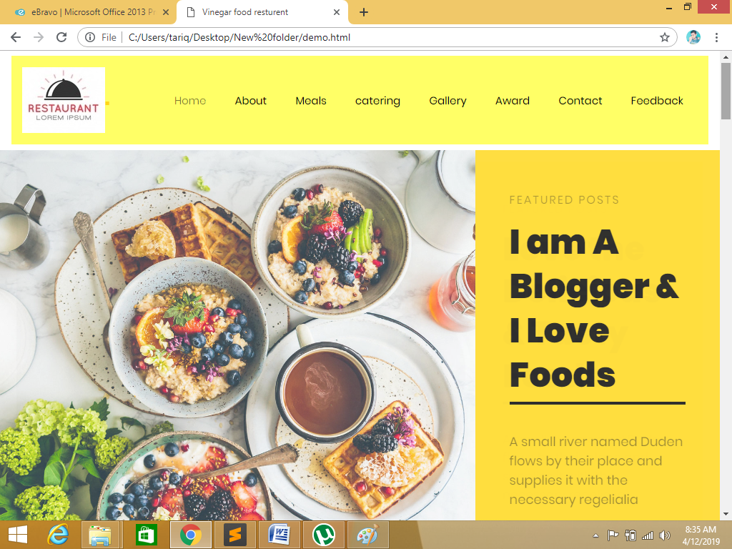

Figure 11 home page snapshot

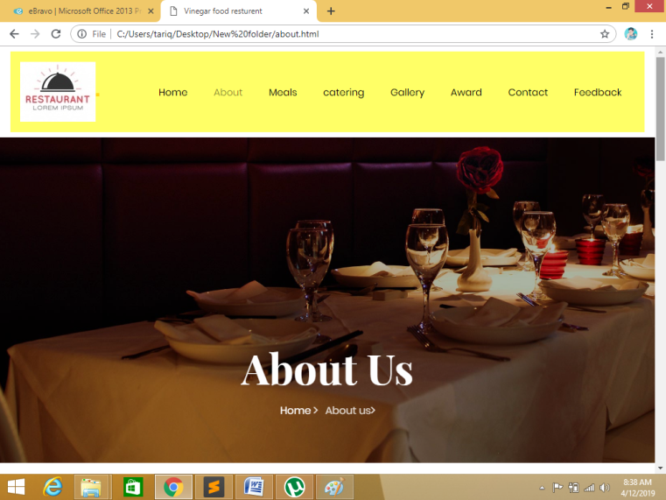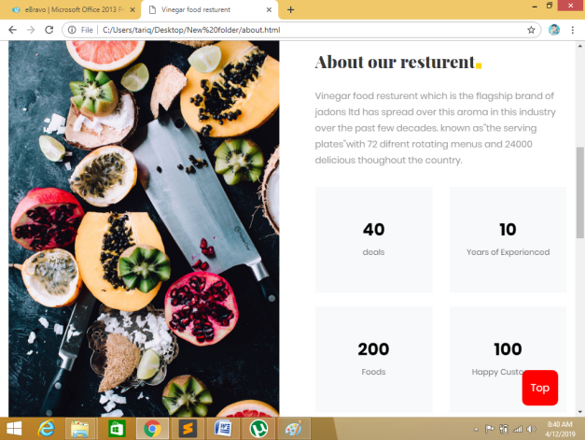

Figure about page snapshot

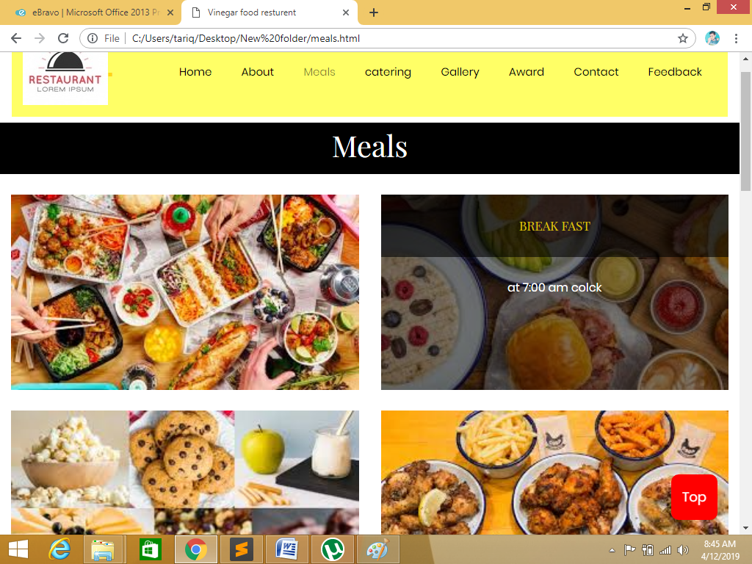

Figure 13 MEALS snapshot

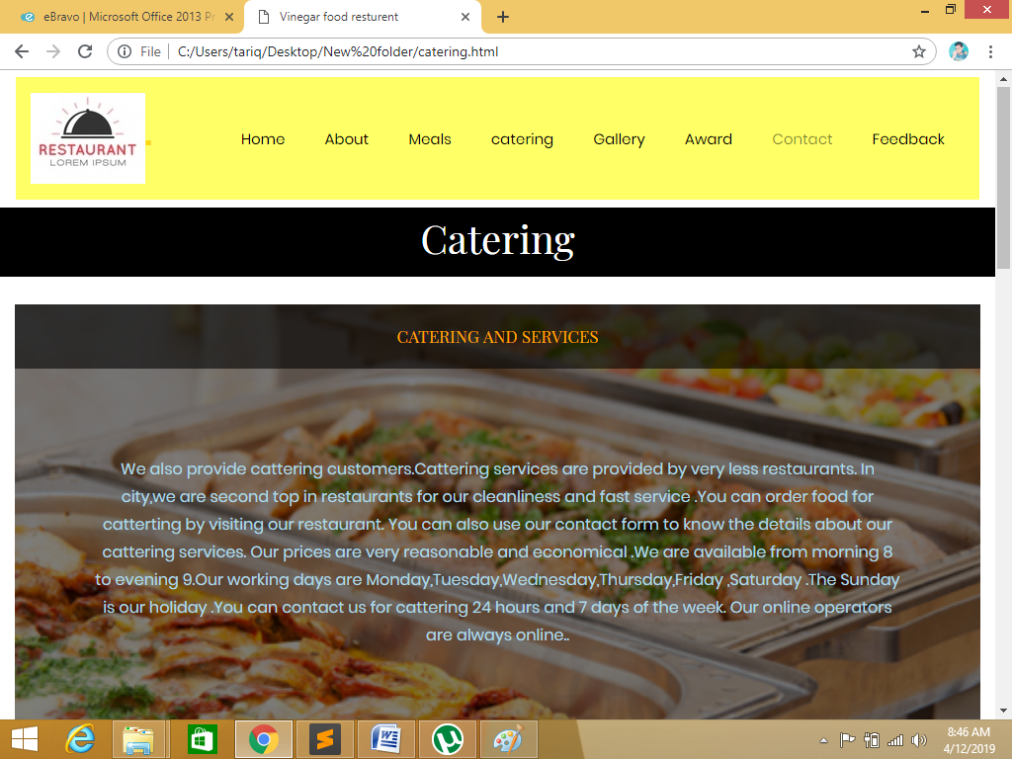

Figure 14 CATERING page snapshot

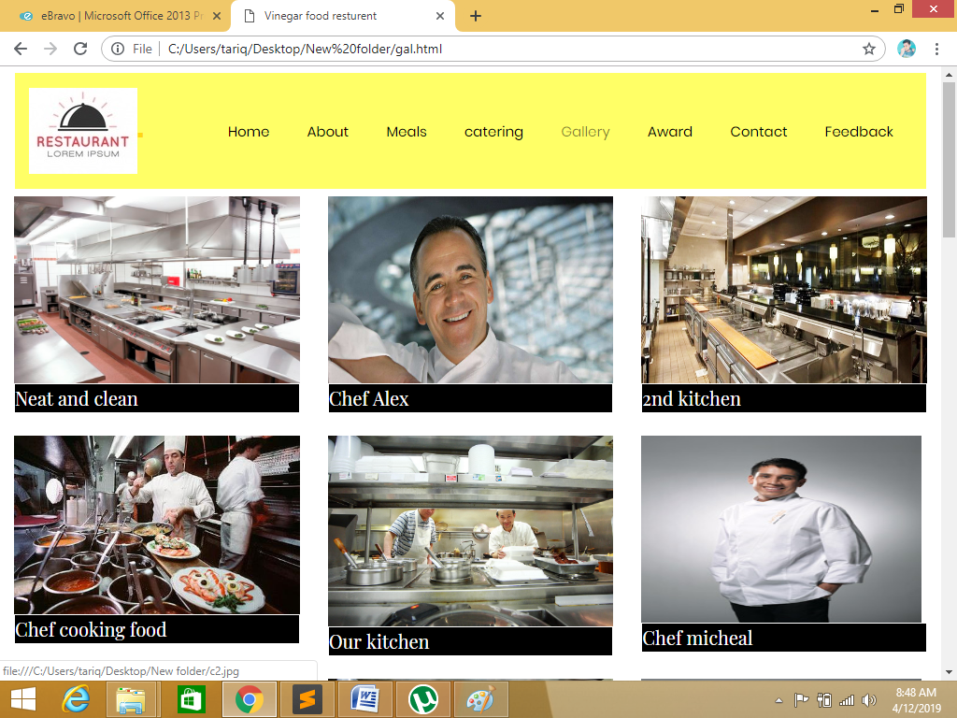

Figure GALERY

This is our slider and religion images where user can see photos.

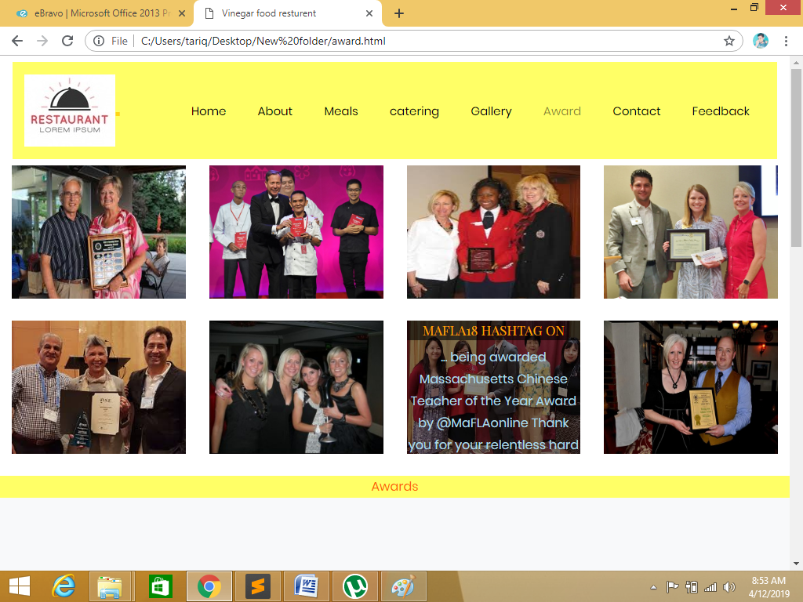

Figure AWRD

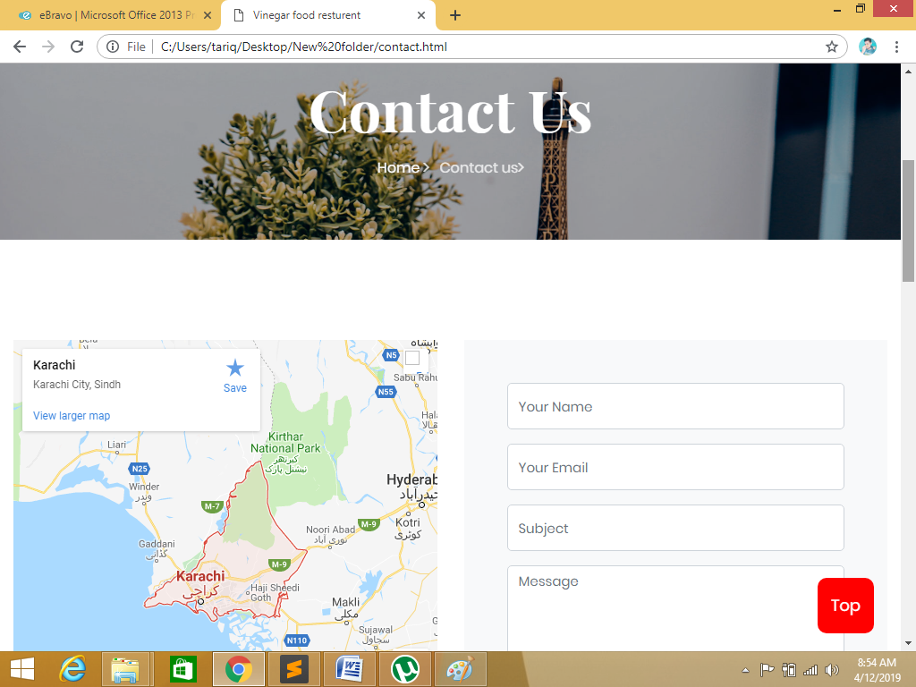

Figure CONTACT

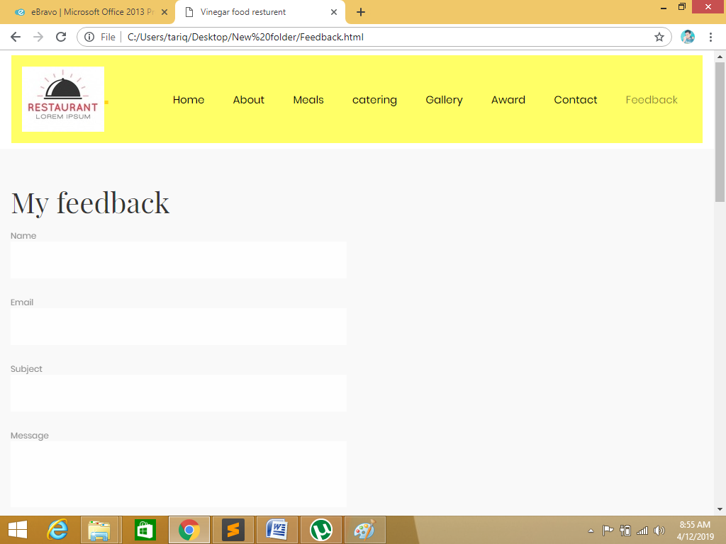

Figure FEEDBACK

# User guide

## Home page layout.

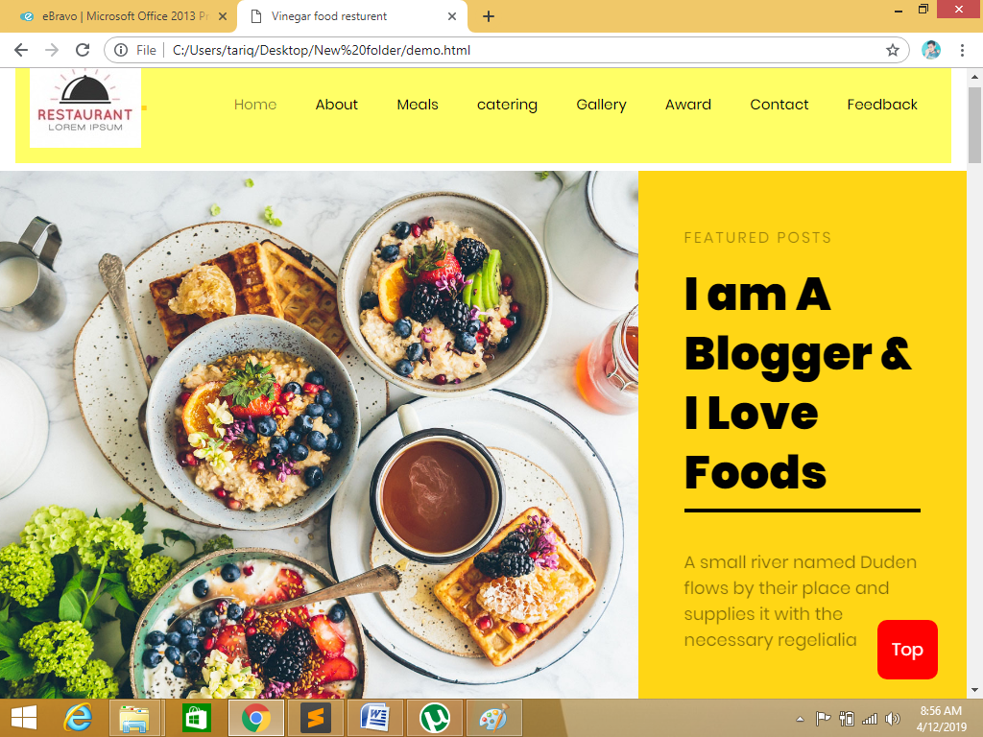

This is our home page

This is our navigation-bar

This is our suitable logo

## About page layout.

There are feature event

This is a Special Offer

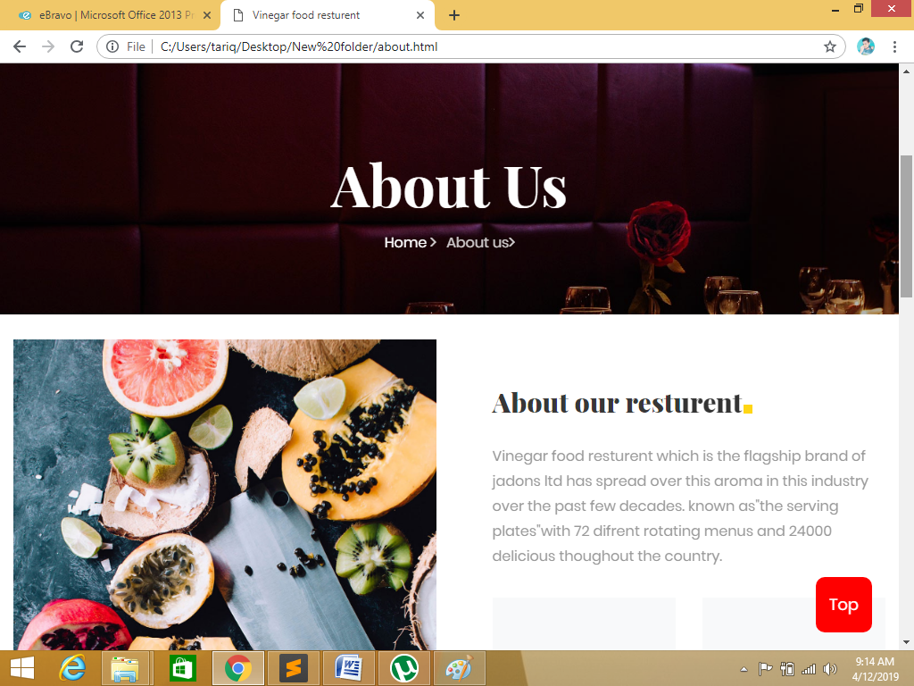

This is our footer section, where user can click different links to see other pages

## Gallery page layout.

There are feature event

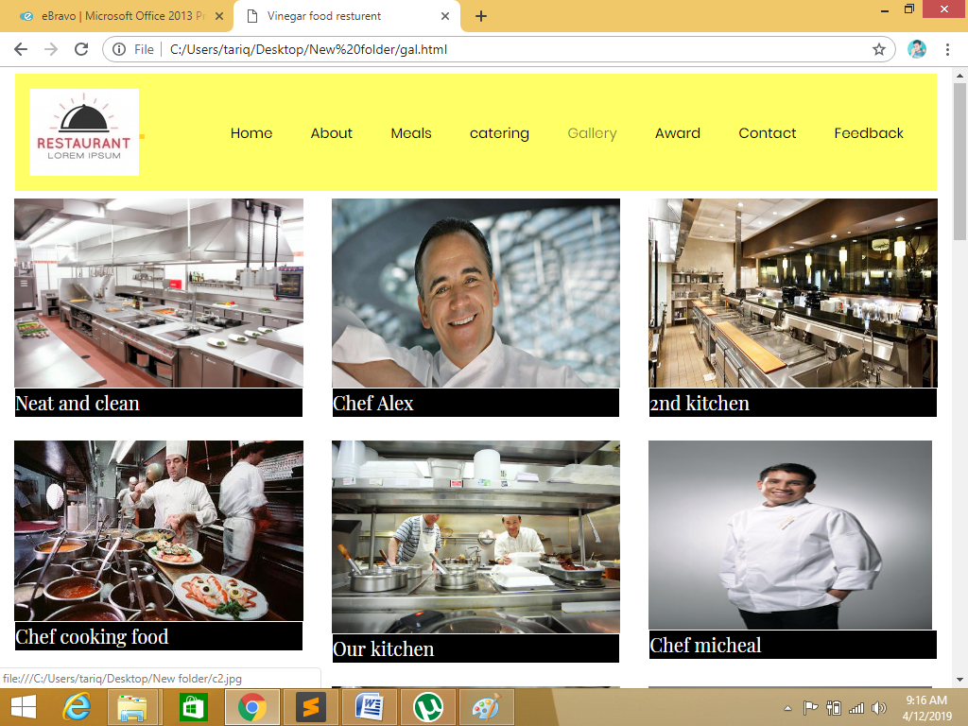

This is a Special Offer

## Contact us

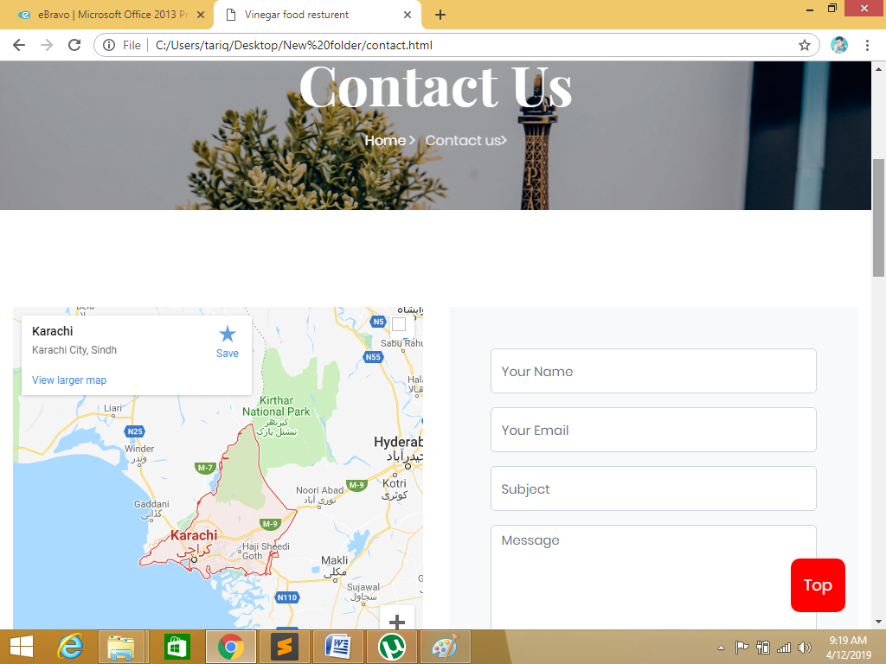

You can contact with ous to send a message

## FOOOTER

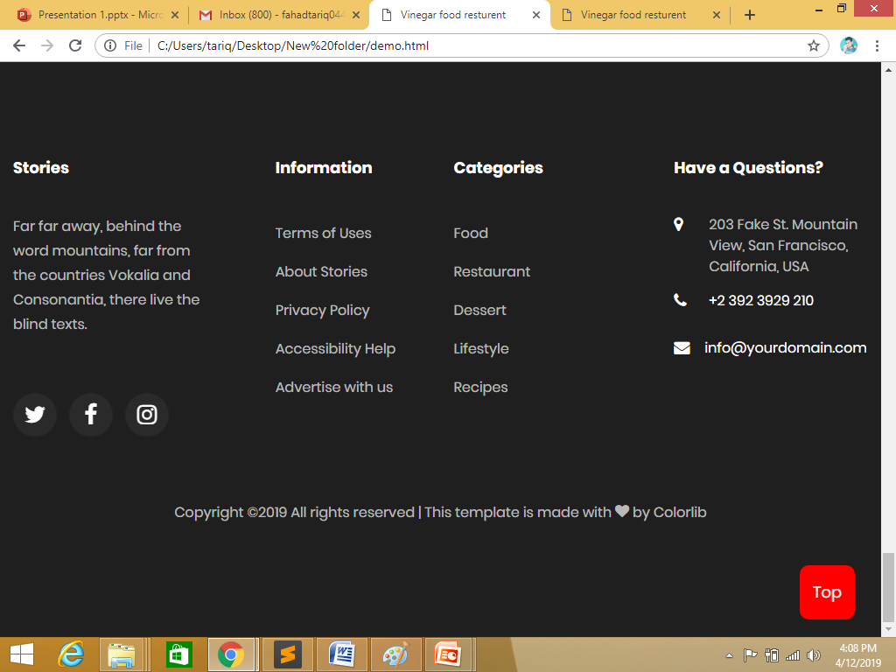

This is our contact information

## Meals

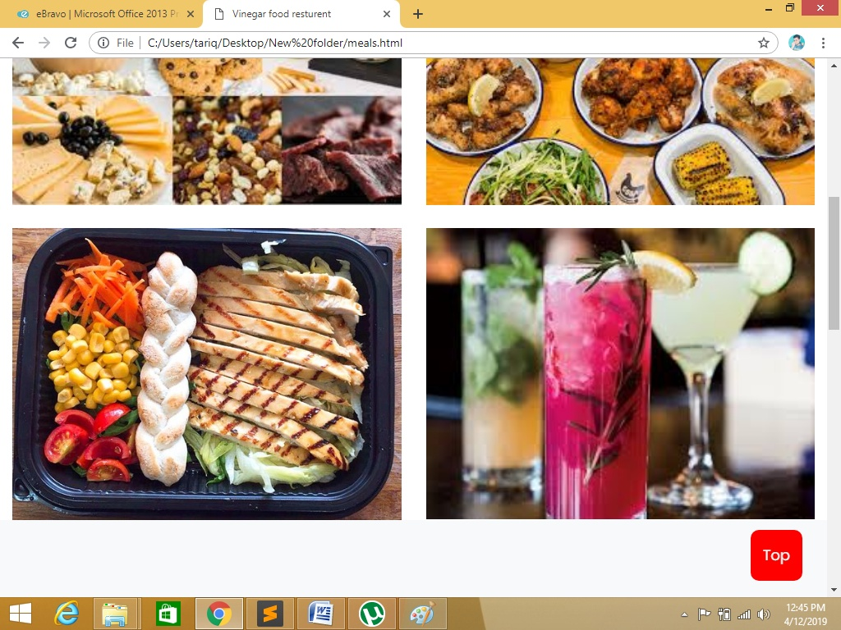

Meals our resturent

## Catering

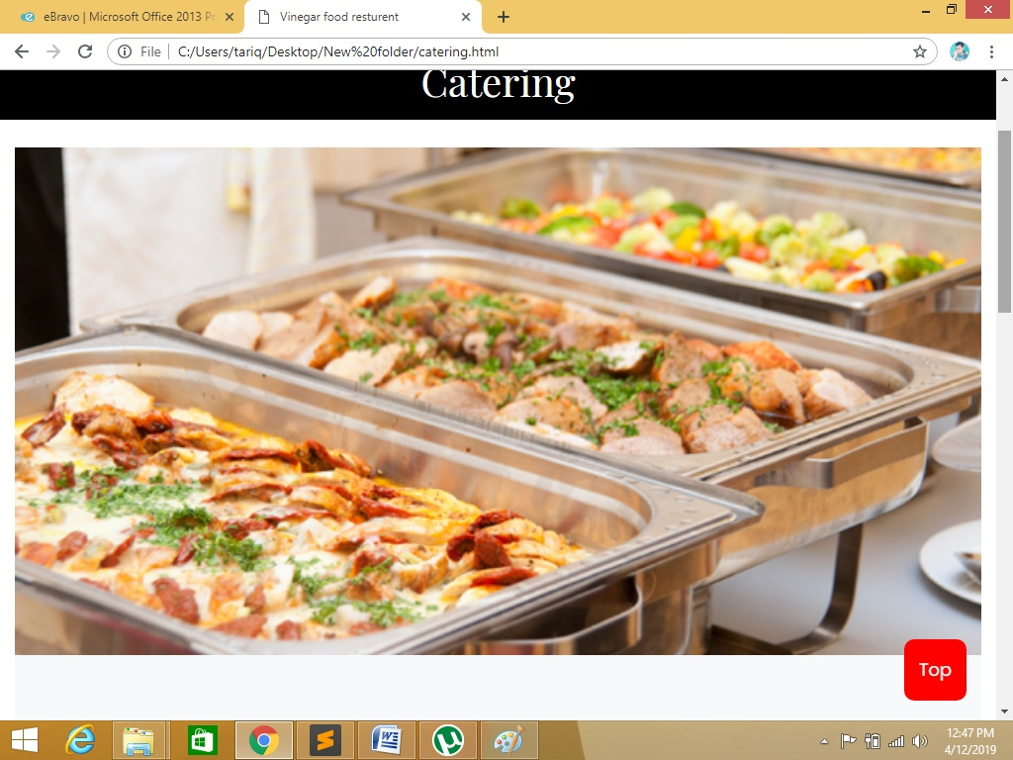

Catering

## Award

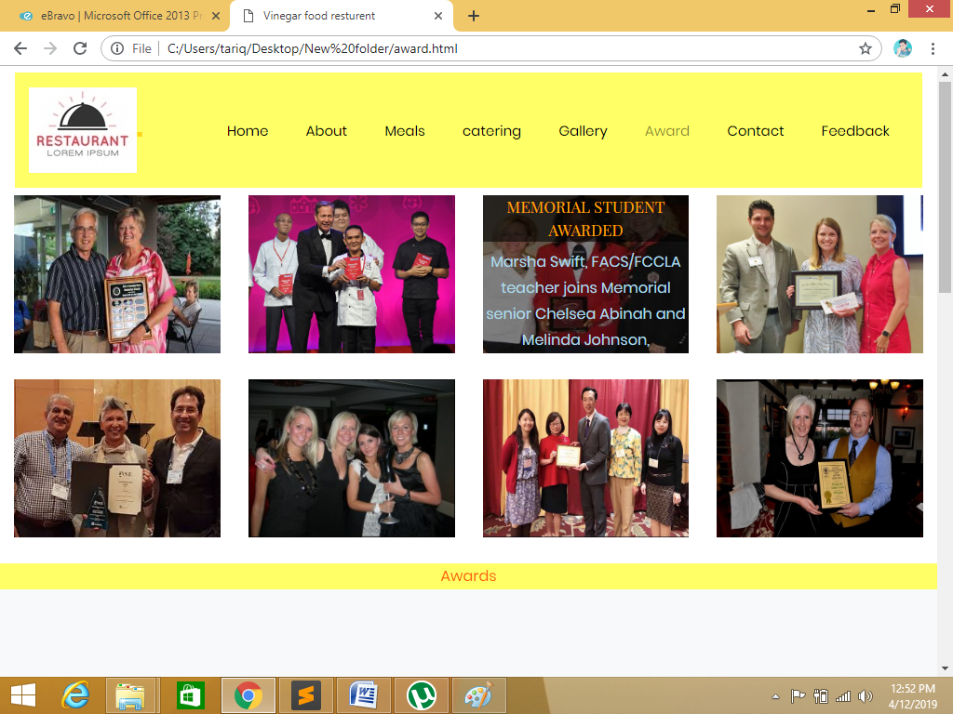

Our resturent owner awards

# References

|  |  |
| --- | --- |
| [1] | "jQuery," [Online]. Available: http://jquery.com/. |
| [2] | Bootstrap. [Online]. Available: http://getbootstrap.com/. |
| [3] | F. Awesome. [Online]. Available: http://fortawesome.github.io/Font-Awesome/. |
| [4] | "Bootstrap Support," [Online]. Available: http://getbootstrap.com/getting-started/#support. |
| [5] | "Bootstrap Grid System," [Online]. Available: http://getbootstrap.com/css/#grid. |

**[6]** **<script src="top.js" type="text/javascript"></script>**

# Appendix I –Source code

## Main style sheet

/*----------------------------------------*/

/* 1. Theme default CSS

/*----------------------------------------*/

/*-- Google Font --*/

@import url("https://fonts.googleapis.com/css?family=Montserrat:100,200,300,400,500,600,700,800,900|Open+Sans:300,400,400i,600,700");

/*-- Common Style --*/

*, *::after, *::before { -webkit-box-sizing: border-box; box-sizing: border-box; }

@import 'bootstrap/bootstrap';

@import 'bootstrap/variables';

$font-primary: 'Poppins',Arial, sans-serif;

$font-secondary: 'Playfair Display', serif;

$white: #fff;

$black: #000000;

$darken: #1f1f1f;

$primary: #fd5f00;

$secondary: #ffd615;

@mixin border-radius($radius) {

-webkit-border-radius: $radius;

-moz-border-radius: $radius;

-ms-border-radius: $radius;

border-radius: $radius;

}

@mixin transition($transition) {

-moz-transition: all $transition ease;

-o-transition: all $transition ease;

-webkit-transition: all $transition ease;

-ms-transition: all $transition ease;

transition: all $transition ease;

}

@mixin gradient-background(){

background: rgba(107,117,255,1);

background: -moz-linear-gradient(45deg, rgba(107,117,255,1) 0%, rgba(107,117,255,1) 0%, rgba(89,183,255,1) 100%);

background: -webkit-gradient(left bottom, right top, color-stop(0%, rgba(107,117,255,1)), color-stop(0%, rgba(107,117,255,1)), color-stop(100%, rgba(89,183,255,1)));

background: -webkit-linear-gradient(45deg, rgba(107,117,255,1) 0%, rgba(107,117,255,1) 0%, rgba(89,183,255,1) 100%);

background: -o-linear-gradient(45deg, rgba(107,117,255,1) 0%, rgba(107,117,255,1) 0%, rgba(89,183,255,1) 100%);

background: -ms-linear-gradient(45deg, rgba(107,117,255,1) 0%, rgba(107,117,255,1) 0%, rgba(89,183,255,1) 100%);

background: linear-gradient(45deg, rgba(107,117,255,1) 0%, rgba(107,117,255,1) 0%, rgba(89,183,255,1) 100%);

filter: progid:DXImageTransform.Microsoft.gradient( startColorstr='#6b75ff', endColorstr='#59b7ff', GradientType=1 );

}

html {

// overflow-x: hidden;

}

body {

font-family: $font-primary;

background: $white;

font-size: 16px;

line-height: 1.8;

font-weight: 400;

color: lighten($black,60%);

&.menu-show {

overflow: hidden;

position: fixed;

height: 100%;

width: 100%;

}

}

a {

transition: .3s all ease;

color: $primary;

&:hover, &:focus {

text-decoration: none;

color: $primary;

outline: none !important;

}

}

h1, h2, h3, h4, h5,

.h1, .h2, .h3, .h4, .h5 {

line-height: 1.5;

color: rgba(0,0,0,.8);

font-weight: 400;

font-family: $font-secondary;

}

.container{

max-width: 1200px;

}

.text-primary {

color: $primary!important;

}

.ftco-navbar-light {

background: transparent!important;

// position: absolute;

// top: -8px;

// left: 0;

// right: 0;

z-index: 3;

@include media-breakpoint-down(md) {

background: $black!important;

position: relative;

top: 0;

padding-top: 0;

padding-bottom: 0;

padding-left: 0;

}

.navbar-brand {

color: $black;

padding-top: 1rem;

padding-bottom: 1rem;

@include media-breakpoint-down(md){

color: $white;

padding-top: 1rem;

padding-bottom: 1rem;

padding-left: 1rem;

}

}

.navbar-nav {

@include media-breakpoint-down(md){

padding-bottom: 20px;

margin-left: 20px !important;

margin-right: 0;

}

> .nav-item {

> .nav-link {

font-size: 15px;

padding-top: 1rem;

padding-bottom: 1rem;

padding-left: 20px;

padding-right: 20px;

color: $black;

font-weight: 400;

&:hover, &:focus {

color: $black;

}

opacity: 1!important;

@include media-breakpoint-down(md){

padding-left: 0;

padding-right: 0;

padding-bottom: 0;

color: $white;

}

}

.dropdown-menu{

border: none;

background: $white;

-webkit-box-shadow: 0px 10px 34px -20px rgba(0,0,0,0.41);

-moz-box-shadow: 0px 10px 34px -20px rgba(0,0,0,0.41);

box-shadow: 0px 10px 34px -20px rgba(0,0,0,0.41);

}

&.ftco-seperator {

position: relative;

margin-left: 20px;

padding-left: 20px;

@include media-breakpoint-down(md) {

padding-left: 0;

margin-left: 0;

}

&:before {

position: absolute;

content: "";

top: 10px;

bottom: 10px;

left: 0;

width: 2px;

background: rgba($white, .05);

@include media-breakpoint-down(md) {

display: none;

}

}

}

&.cta {

> a {

color: $white;

border: 1px solid $primary;

background: $primary;

@include border-radius(2px);

span {

display: inline-block;

color: $white;

}

&:hover{

background: $primary;

border: 1px solid $primary;

}

}

&.cta-colored {

a{

border: 1px solid $secondary;

background: $secondary !important;

}

}

}

&.active {

> a {

color: rgba(0,0,0,.5);

}

}

@include media-breakpoint-down(md){

&.active {

> a {

color: $primary;

}

}

}

}

}

.navbar-toggler {

border: none;

color: rgba(255,255,255,.5)!important;

cursor: pointer;

padding-right: 0;

text-transform: uppercase;

font-size: 16px;

letter-spacing: .1em;

&:hover, &:focus {

text-decoration: none;

color: $primary;

outline: none !important;

}

}

&.scrolled {

position: fixed;

right: 0;

left: 0;

top: 0;

margin-top: -130px;

background: $white!important;

box-shadow: 0 0 10px 0 rgba(0,0,0,.1);

padding: 0;

.nav-item {

> .nav-link{

@include media-breakpoint-down(md){

padding-left: 0 !important;

padding-right: 0 !important;

padding-bottom: 0 !important;

}

}

&.active {

> a {

color: $primary!important;

}

}

&.cta {

> a {

color: $white !important;

background: $primary;

border: none !important;

padding-top: .5rem!important;

padding-bottom: .5rem !important;

padding-left: 20px !important;

padding-right: 20px !important;

margin-top: 6px !important;

@include border-radius(5px);

span {

display: inline-block;

color: $white !important;

}

}

&.cta-colored {

span {

border-color: $primary;

}

}

}

}

.navbar-nav {

@include media-breakpoint-down(md) {

background: none;

border-radius: 0px;

padding-left: 1rem!important;

padding-right: 1rem!important;

margin-left: 0 !important;

}

}

.navbar-toggler {

border: none;

color: rgba(0,0,0,.5)!important;

border-color: rgba(0,0,0,.5)!important;

cursor: pointer;

margin-right: 15px !important;

text-transform: uppercase;

font-size: 16px;

letter-spacing: .1em;

}

.nav-link {

padding-top: 1rem!important;

padding-bottom: 1rem!important;

color: $black!important;

&.active {

color: $primary!important;

}

}

&.awake {

margin-top: 0px;

transition: .3s all ease-out;

}

&.sleep {

transition: .3s all ease-out;

}

.navbar-brand {

color: $black;

padding-top: 1rem;

padding-bottom: 1rem;

}

}

}

.navbar-brand {

font-weight: 400;

font-size: 24px;

font-weight: 900;

position: relative;

span{

color: $secondary;

}

&:hover, &:focus{

color: $black !important;

}

}

//OWL CAROUSEL

.owl-carousel {

position: relative;

.owl-item {

opacity: .4;

&.active {

opacity: 1;

}

}

.owl-dots {

text-align: center;

.owl-dot {

width: 10px;

height: 10px;

margin: 5px;

border-radius: 50%;

background: lighten($black, 90%);

position: relative;

&:after{

position: absolute;

top: -2px;

left: -2px;

right: 0;

bottom: 0;

width: 14px;

height: 14px;

content: '';

border:1px solid rgba(255,255,255,.3);

@include border-radius(50%);

}

&:hover, &:focus{

outline: none !important;

}

&.active {

background: lighten($black, 70%);

}

}

}

&.home-slider {

position: relative;

height: 680px;

z-index: 0;

.slider-item {

background-size: cover;

background-repeat: no-repeat;

background-position: center center;

height: 680px;

position: relative;

z-index: 0;

@include media-breakpoint-down(lg){

background-position: center center !important;

}

.overlay{

position: absolute;

top: 0;

bottom: 0;

left: 0;

right: 0;

background: $black;

opacity: .3;

}

.slider-text {

height: 680px;

z-index: 0;

@include media-breakpoint-down(sm){

text-align: center;

}

.img{

width: 66%;

// max-width: 66%;

height: 680px;

z-index: -1;

@include media-breakpoint-down(sm){

width: 100%;

}

}

.text{

width: 34%;

// max-width: 34%;

background: $secondary;

height: 680px;

z-index: 1;

.text-2{

position: relative;

}

@include media-breakpoint-down(sm){

width: 100%;

position: absolute;

top: 0;

left: 0;

right: 0;

bottom: 0;

background: transparent;

h1{

color: $white;

&:after{

background: $white;

}

}

.subheading{

color: rgba(255,255,255,.9);

}

p{

color: rgba(255,255,255,.9);

}

}

}

h1 {

font-size: 48px;

color: $black;

line-height: 1.3;

font-weight: 900;

position: relative;

font-family: $font-primary;

&:after{

position: absolute;

bottom: -10px;

left: 0;

right: 0;

content: '';

width: 100%;

height: 4px;

background: $black;

}

@include media-breakpoint-down(md) {

font-size: 30px;

}

}

.subheading{

font-size: 16px;

font-weight: 400;

font-family: $font-primary;

// text-transform: uppercase;

color: rgba(0,0,0,.4);

text-transform: uppercase;

letter-spacing: 2px;

}

p {

font-size: 18px;

line-height: 1.5;

font-weight: 400;

color: rgba(0,0,0,.5);

}

.btn-custom{

font-weight: 400;

// color: $black;

}

}

}

.owl-nav {

position: absolute;

bottom: 90px !important;

left: 0;

right: 0;

max-width: 1200px;

margin: 0 auto;

@include media-breakpoint-down(md){

display: none;

}

.owl-prev,

.owl-next {

position: absolute;

width: 17.1%;

height: 90px;

// color: $primary !important;

background: $white !important;

border: 1px solid rgba(0,0,0,.1);

border-top: none;

@include transition(.7s);

span {

&:before {

font-size: 20px;

margin-top: 7px;

color: $black;

}

}

p{

margin-bottom: 0;

font-size: 20px;

}

opacity: 1;

}

.owl-prev {

top: 0 !important;

right: 0 !important;

@include media-breakpoint-up(lg){

right: 17% !important;

margin-right: -1px;

}

&:hover, &:focus{

background: $black !important;

outline: none !important;

span {

&:before {

font-size: 20px;

margin-top: 7px;

color: $white;

}

}

p{

color: $white;

}

}

}

.owl-next {

top: 0 !important;

right: 0 !important;

@include media-breakpoint-up(lg){

right: 0 !important;

}

&:hover, &:focus{

background: $black !important;

outline: none !important;

span {

&:before {

font-size: 20px;

margin-top: 7px;

color: $white;

}

}

p{

color: $white;

}

}

}

}

.owl-dots {

position: absolute;

left: 0;

right: 0;

bottom: 60px;

width: 100%;

text-align: center;

display: none;

@include media-breakpoint-down(md){

bottom: 5px;

display: block;

}

.owl-dot {

width: 10px;

height: 10px;

margin: 5px;

border-radius: 50%;

background: rgba(255,255,255,.4);

&.active {

background: $white;

}

}

}

}

}

.hero-wrap{

width: 100%;

height: 500px;

position: relative;

background-size: cover;

background-repeat: no-repeat;

background-position: center center;

@include media-breakpoint-down(md){

background-position: top center !important;

}

.overlay{

position: absolute;

top: 0;

left: 0;

right: 0;

bottom: 0;

content: '';

opacity: .3;

background: $black;

}

&.hero-wrap-2{

.overlay{

width: 100%;

opacity: .3;

}

}

.slider-text{

height: 500px;

h1 {

font-size: 64px;

color: $white;

line-height: 1.2;

font-weight: 700;

@include media-breakpoint-down(md) {

font-size: 40px;

}

// span{

// font-size: 54px;

// font-weight: 700;

// }

}

p {

font-size: 20px;

line-height: 1.5;

font-weight: 300;

color: rgba(255,255,255,.8);

strong{

font-weight: 700;

a{

color: $black;

}

}

}

.breadcrumbs{

font-size: 16px;

margin-bottom: 20px;

z-index: 99;

font-weight: 400;

span{

color: rgba(255,255,255,.8);

i{

color: rgba(255,255,255,.8);

}

a{

color: rgba(255,255,255,1);

&:hover, &:focus{

color: $primary;

i{

color: $primary;

}

}

}

}

}

.bread{

font-weight: 700;

}

}

}

.bg-light {

background: #f8f9fa!important;

}

.bg-primary{

background: $primary;

}

.bg-secondary{

background: $secondary !important;

}

//BUTTON

.btn {

cursor: pointer;

@include border-radius(3px);

// box-shadow: none!important;

-webkit-box-shadow: 0px 24px 36px -11px rgba(0,0,0,0.09);

-moz-box-shadow: 0px 24px 36px -11px rgba(0,0,0,0.09);

box-shadow: 0px 24px 36px -11px rgba(0,0,0,0.09);

&:hover, &:active, &:focus {

outline: none;

}

&.btn-primary {

background: $primary !important;

border: 1px solid $primary !important;

color: $white !important;

&:hover {

border: 1px solid $primary;

background: transparent;

color :$primary;

}

&.btn-outline-primary {

border: 1px solid $primary;

background: transparent;

color :$primary;

&:hover {

border: 1px solid transparent;

background: $primary;

color :$white;

}

}

}

&.btn-outline-white {

border-color: rgba($white, .8);

background: none;

@include border-radius(5px);

border-width: 1px;

color: $white;

&:hover, &:focus, &:active {

background: $white;

border-color: $white;

color: $primary;

}

}

&.btn-black {

background: $black !important;

border: 1px solid $black !important;

color: $white !important;

&:hover {

border: 1px solid $primary !important;

background: $primary !important;

color :$white;

}

&.btn-outline-black {

border: 1px solid $black;

background: transparent;

color :$primary;

&:hover {

border: 1px solid transparent;

background: $black;

color :$white;

}

}

}

}

//BLOG ENTRY

.blog-entry{

margin-bottom: 3em;

width: 100%;

.text{

h3{

font-size: 20px;

margin-bottom: 20px;

a{

color: $black;

}

}

.meta{

position: relative;

z-index: 0;

margin-bottom: 10px;

&:after{

z-index: -1;

position: absolute;

top: 50%;

left: 0;

right: 0;

content: '';

width: 100%;

height: 1px;

background: $black;

}

span{

background: $white;

}

}

}

.img{

height: 180px;

@include border-radius(4px);

&.img-big{

height: 700px;

position: relative;

.overlay{

position: absolute;

top: 0;

left: 0;

right: 0;

bottom: 0;

content: '';

opacity: .5;

background: rgba(0,0,0,0);

background: -moz-linear-gradient(top, rgba(0,0,0,0) 17%, rgba(0,0,0,0) 27%, rgba(0,0,0,1) 100%);

background: -webkit-gradient(left top, left bottom, color-stop(17%, rgba(0,0,0,0)), color-stop(27%, rgba(0,0,0,0)), color-stop(100%, rgba(0,0,0,1)));

background: -webkit-linear-gradient(top, rgba(0,0,0,0) 17%, rgba(0,0,0,0) 27%, rgba(0,0,0,1) 100%);

background: -o-linear-gradient(top, rgba(0,0,0,0) 17%, rgba(0,0,0,0) 27%, rgba(0,0,0,1) 100%);

background: -ms-linear-gradient(top, rgba(0,0,0,0) 17%, rgba(0,0,0,0) 27%, rgba(0,0,0,1) 100%);

background: linear-gradient(to bottom, rgba(0,0,0,0) 17%, rgba(0,0,0,0) 27%, rgba(0,0,0,1) 100%);

filter: progid:DXImageTransform.Microsoft.gradient( startColorstr='#000000', endColorstr='#000000', GradientType=0 );

}

.text{

display: block;

width: 100%;

padding: 2em 3em 7em 3em;;

position: relative;

h3{

font-size: 40px;

a{

color: $white;

}

}

.subheading{

color: $secondary;

}

.btn-custom{

position: absolute;

bottom: 0;

right: 0;

padding: 1em 2em;

background: $white;

color: $black;

}

}

}

&.img-big-2{

height: 500px;

.overlay{

position: absolute;

top: 0;

left: 0;

right: 0;

bottom: 0;

content: '';

opacity: .7;

background: rgba(0,0,0,0);

background: -moz-linear-gradient(top, rgba(0,0,0,0) 17%, rgba(0,0,0,0) 27%, rgba(0,0,0,1) 100%);

background: -webkit-gradient(left top, left bottom, color-stop(17%, rgba(0,0,0,0)), color-stop(27%, rgba(0,0,0,0)), color-stop(100%, rgba(0,0,0,1)));

background: -webkit-linear-gradient(top, rgba(0,0,0,0) 17%, rgba(0,0,0,0) 27%, rgba(0,0,0,1) 100%);

background: -o-linear-gradient(top, rgba(0,0,0,0) 17%, rgba(0,0,0,0) 27%, rgba(0,0,0,1) 100%);

background: -ms-linear-gradient(top, rgba(0,0,0,0) 17%, rgba(0,0,0,0) 27%, rgba(0,0,0,1) 100%);

background: linear-gradient(to bottom, rgba(0,0,0,0) 17%, rgba(0,0,0,0) 27%, rgba(0,0,0,1) 100%);

filter: progid:DXImageTransform.Microsoft.gradient( startColorstr='#000000', endColorstr='#000000', GradientType=0 );

}

.text{

display: block;

width: 100%;

padding: 2em 3em 5em 3em;;

position: relative;

h3{

font-size: 40px;

line-height: 1.2;

a{

color: $white;

}

}

.subheading{

color: $secondary;

}

.btn-custom{

position: absolute;

bottom: 0;

right: 0;

padding: 1em 2em;

background: $white;

color: $black;

}

}

}

}

.img-2{

display: block;

width: 100%;

overflow: hidden;

@include border-radius(4px);

img{

-webkit-transform: scale(1.0);

-moz-transform: scale(1.0);

-o-transform: scale(1.0);

transform: scale(1.0);

@include transition(.3s);

}

}

&:hover{

.img-2{

img{

-webkit-transform: scale(1.2);

-moz-transform: scale(1.2);

-o-transform: scale(1.2);

transform: scale(1.2);

}

}

}

.half{

width: 100%;

display: block;

@include media-breakpoint-up(lg){

width: 50%;

}

.img{

height: 380px;

}

h3{

font-size: 30px;

font-weight: 700;

}

}

}

//FTCO_ABOUT

.ftco-section-about{

.text{

background: $darken;

@include media-breakpoint-up(md){

margin-top: -4em;

}

.text-2{

position: relative;

z-index: 0;

}

}

h1 {

font-size: 70px;

color: $white;

line-height: 1.2;

font-weight: 700;

position: relative;

@include media-breakpoint-down(md) {

font-size: 30px;

}

}

.subheading{

font-size: 16px;

font-weight: 400;

font-family: $font-primary;

// text-transform: uppercase;

color: rgba(255,255,255,.4);

text-transform: uppercase;

letter-spacing: 2px;

}

p {

font-size: 18px;

line-height: 1.5;

font-weight: 400;

color: rgba(255,255,255,.4);

}

.btn-custom{

font-weight: 400;

color: rgba(255,255,255,.3);

}

.signature{

font-style: italic;

font-size: 24px;

font-family: $font-secondary;

color: rgba(255,255,255,.2);

text-decoration: underline;

}

}

// USEFUL CODE

.form-control {

height: 52px!important;

background: $white!important;

color: $black!important;

font-size: 18px;

border-radius: 5px;

box-shadow: none!important;

&:focus, &:active {

border-color: $black;

}

}

textarea.form-control {

height: inherit!important;

}

.ftco-vh-100 {

height: 100vh;

@include media-breakpoint-down(lg) {

height: inherit;

padding-top: 5em;

padding-bottom: 5em;

}

}

.ftco-animate {

opacity: 0;

visibility: hidden;

}

.bg-primary {

background: $primary!important;

}

.bg-darken {

background: $darken;

}

.about-author{

img{

}

.desc{

h3{

font-size: 24px;

}

}

.bio{

}

}

.ftco-section {

padding: 7em 0;

position: relative;

z-index: 0;

@include media-breakpoint-down(sm){

padding: 6em 0;

}

}

.ftco-no-pt{

padding-top: 0 !important;

}

.ftco-no-pb{

padding-bottom: 0 !important;

}

.ftco-bg-dark {

background: #3c312e;

}

.ftco-subscribe{

width: 100%;

display: block;

z-index: 0;

}

.subscribe-form{

.form-group {

position: relative;

margin-bottom: 0;

@include border-radius(0);

input {

height: 64px !important;

border: 1px solid transparent;

color: rgba(0,0,0,.7) !important;

font-size: 20px;

background: rgba(0,0,0,.05) !important;

border-radius: 5px 0px 0px 5px;

padding: 0 20px;

&::-webkit-input-placeholder { /* Chrome/Opera/Safari */

color: rgba(0,0,0,.5) !important;

}

&::-moz-placeholder { /* Firefox 19+ */

color: rgba(0,0,0,.5) !important;

}

&:-ms-input-placeholder { /* IE 10+ */

color: rgba(0,0,0,.5) !important;

}

&:-moz-placeholder { /* Firefox 18- */

color: rgba(0,0,0,.5) !important;

}

}

.submit{

color: $white !important;

background: $black !important;

border-radius: 0px 5px 5px 0px;

font-size: 16px;

&:hover{

cursor: pointer;

}

}

}

.icon {

position: absolute;

top: 50%;

right: 20px;

transform: translateY(-50%);

color: rgba(255,255,255,.8);

}

}

.ftco-footer {

font-size: 16px;

background: $darken;

padding: 7em 0;

z-index: 0;

.ftco-footer-logo {

text-transform: uppercase;

letter-spacing: .1em;

}

.ftco-footer-widget {

h2 {

font-weight: normal;

color: $white;

margin-bottom: 40px;

font-size: 18px;

font-weight: 700;

font-family: $font-primary;

}

ul{

li{

a{

color: rgba(255,255,255,.7);

span{

color: $white;

}

}

}

}

.btn-primary{

background: $white !important;

border: 2px solid $white !important;

&:hover{

background: $white;

border: 2px solid $white !important;

}

}

}

p {

color: rgba($white, .7);

}

a {

color: rgba($white, .7);

&:hover {

color: $white;

}

}

.ftco-heading-2 {

font-size: 17px;

font-weight: 400;

color: $black;

}

}

.ftco-footer-social {

li {

list-style: none;

margin: 0 10px 0 0;

display: inline-block;

a {

height: 50px;

width: 50px;

display: block;

float: left;

background: rgba($white, .05);

border-radius: 50%;

position: relative;

span {

position: absolute;

font-size: 26px;

top: 50%;

left: 50%;

transform: translate(-50%, -50%);

}

&:hover {

color: $white;

}

}

}

}

.footer-small-nav {

> li {

display: inline-block;

a {

margin: 0 10px 10px 0;

&:hover, &:focus {

color: $primary;

}

}

}

}

.media {

.ftco-icon {

width: 100px;

span {

color: $primary;

}

}

}

.ftco-media {

background: $white;

border-radius: 0px;

.heading {

font-weight: normal;

}

&.ftco-media-shadow {

padding: 40px;

background: $white;

box-shadow: 0 10px 50px -15px rgba(0,0,0,.3);

transition: .2s all ease;

position: relative;

top: 0;

&:hover, &:focus {

top: -3px;

box-shadow: 0 10px 70px -15px rgba(0,0,0,.3);

}

}

.icon {

font-size: 50px;

display: block;

color: $primary;

}

&.text-center {

.ftco-icon {

margin: 0 auto;

}

}

}

.ftco-overflow-hidden {

overflow: hidden;

}

.padding-top-bottom {

padding-top: 120px;

padding-bottom: 120px;

}

// Map

#map {

// height: 400px;

width: 100%;

@include media-breakpoint-down(md) {

height: 300px;

}

}

@-webkit-keyframes pulse {

0% {

-webkit-box-shadow: 0 0 0 0 rgba($primary, 0.4);

}

70% {

-webkit-box-shadow: 0 0 0 30px rgba($primary, 0);

}

100% {

-webkit-box-shadow: 0 0 0 0 rgba($primary, 0);

}

}

@keyframes pulse {

0% {

-moz-box-shadow: 0 0 0 0 rgba($primary, 0.4);

box-shadow: 0 0 0 0 rgba($primary, 0.4);

}

70% {

-moz-box-shadow: 0 0 0 30px rgba($primary, 0);

box-shadow: 0 0 0 30px rgba($primary, 0);

}

100% {

-moz-box-shadow: 0 0 0 0 rgba($primary, 0);

box-shadow: 0 0 0 0 rgba($primary, 0);

}

}

.heading-section{

.subheading{

font-size: 18px;

display: block;

margin-bottom: 5px;

}

h2{

font-size: 30px;

font-weight: 900;

span{

position: relative;

&:after{

position: absolute;

bottom: 7px;

right: -12px;

width: 10px;

height: 10px;

content: '';

background: $secondary;

}

}

@include media-breakpoint-down(sm){

font-size: 28px;

}

}

&.heading-section-white{

.subheading{

color: rgba(255,255,255,.9);

}

h2{

font-size: 40px;

color: $white;

}

p{

color: rgba(255,255,255,.9);

}

}

}

//COVER BG

.img,

.blog-img,

.user-img{

background-size: cover;

background-repeat: no-repeat;

background-position: center center;

}

.about-image{

@include media-breakpoint-down(sm){

height: 400px;

margin-bottom: 30px;

}

}

// magnific pop up

.image-popup {

cursor: -webkit-zoom-in;

cursor: -moz-zoom-in;

cursor: zoom-in;

}

.mfp-with-zoom .mfp-container,

.mfp-with-zoom.mfp-bg {

opacity: 0;

-webkit-backface-visibility: hidden;

-webkit-transition: all 0.3s ease-out;

-moz-transition: all 0.3s ease-out;

-o-transition: all 0.3s ease-out;

transition: all 0.3s ease-out;

}

.mfp-with-zoom.mfp-ready .mfp-container {

opacity: 1;

}

.mfp-with-zoom.mfp-ready.mfp-bg {

opacity: 0.8;

}

.mfp-with-zoom.mfp-removing .mfp-container,

.mfp-with-zoom.mfp-removing.mfp-bg {

opacity: 0;

}

#section-counter{

position: relative;

z-index: 0;

&:after{

position: absolute;

top: 0;

left: 0;

bottom: 0;

right: 0;

content: '';

z-index: -1;

opacity: 0;

background: $black;

}

}

.ftco-counter {

// padding: 6em 0;

@include media-breakpoint-down(lg){

background-position: center center !important;

}

.img{

display: block;

width: 100%;

@include media-breakpoint-down(sm){

height: 400px;

background-position: top center !important;

}

}

.block-18{

}

.text{

strong.number{

font-weight: 700;

font-size: 30px;

color: $black;

}

span{

display: block;

font-size: 14px;

color: rgba(0,0,0,.7);

margin-bottom: 10px;

}

}

.icon{

width: 70px;

height: 70px;

margin: 0 auto;

// background: lighten($primary,20%);

@include border-radius(50%);

span{

color: $white;

font-size: 48px;

@include gradient-background();

-webkit-background-clip: text;

-webkit-text-fill-color: transparent;

}

}

.counter-wrap{

@include media-breakpoint-down(sm){

margin-bottom: 20px;

}

}

}

.block-23 {

ul {

padding: 0;

li {

&, > a {

display: table;

line-height: 1.5;

margin-bottom: 15px;

}

span{

color: rgba($white, .7);

}

.icon, .text {

display: table-cell;

vertical-align: top;

}

.icon {

width: 40px;

font-size: 18px;

padding-top: 2px;

color: rgba($white, 1);

}

}

}

}

.block-27 {

ul {

padding: 0;

margin: 0;

li {

display: inline-block;

margin-bottom: 4px;

font-weight: 400;

a,span {

color: $darken;

text-align: center;

display: inline-block;

width: 40px;

height: 40px;

line-height: 40px;

border-radius: 50%;

border: 1px solid lighten($black,90%);

}

&.active {

a, span {

background: $darken;

color: $white;

border: 1px solid transparent;

}

}

}

}

}

.contact-section {

.contact-info{

p{

font-size: 14px;

a{

color: lighten($black,10%);

}

span{}

}

}

.box{

width: 100%;

display: block;

.icon{

width: 100px;

height: 100px;

background: rgba(0,0,0,1);

margin: 0 auto;

margin-bottom: 2em;

@include border-radius(50%);

span{

color: $secondary;

font-size: 30px;

}

}

h3{

font-size: 18px;

font-weight: 600;

font-family: $font-primary;

}

}

.contact-form{

width: 100%;

}

}

.block-9 {

.form-control {

outline: none!important;

box-shadow: none!important;

font-size: 15px;

}

#map {

}

}

//### .block-21

.block-21 {

.blog-img{

display: block;

height: 80px;

width: 80px;

}

.text {

width: calc(100% - 100px);

h3 {

font-size: 18px;

font-weight: 400;

font-family: $font-primary;

a {

color: $black;

&:hover, &:active, &:focus {

color: $primary;

}

}

}

.meta {

> div {

display: inline-block;

font-size: 12px;

margin-right: 5px;

a {

color: lighten($black, 50%);

}

}

}

}

}

/* Blog*/

.post-info {

font-size: 12px;

text-transform: uppercase;

font-weight: bold;

color: $white;

letter-spacing: .1em;

> div {

display: inline-block;

.seperator {

display: inline-block;

margin: 0 10px;

opacity: .5;

}

}

}

.tagcloud {

a {

text-transform: uppercase;

display: inline-block;

padding: 4px 10px;

margin-bottom: 7px;

margin-right: 4px;

border-radius: 4px;

color: $black;

border: 1px solid #ccc;

font-size :11px;

&:hover {

border: 1px solid #000;

}

}

}

.comment-form-wrap {

clear: both;

}

.comment-list {

padding: 0;

margin: 0;

.children {

padding: 50px 0 0 40px;

margin: 0;

float: left;

width: 100%;

}

li {

padding: 0;

margin: 0 0 30px 0;

float: left;

width: 100%;

clear: both;

list-style: none;

.vcard {

width: 80px;

float: left;

img {

width: 50px;

border-radius: 50%;

}

}

.comment-body {

float: right;

width: calc(100% - 80px);

h3 {

font-size: 20px;

}

.meta {

text-transform: uppercase;

font-size: 13px;

letter-spacing: .1em;

color: #ccc;

}

.reply {

padding: 5px 10px;

background: lighten($black, 90%);

color: $black;

text-transform: uppercase;

font-size: 11px;

letter-spacing: .1em;

font-weight: 400;

border-radius: 4px;

&:hover {

color: $white;

background: lighten($black, 0%);

}

}

}

}

}

.search-form {

background: lighten($black, 95%);

// padding: 10px;

.form-group {

position: relative;

input {

height: 60px !important;

padding-right: 50px;

font-size: 14px;

border: 1px solid rgba(0,0,0,.09);

}

}

.icon {

position: absolute;

top: 50%;

right: 20px;

transform: translateY(-50%);

}

}

//SIDEBAR

.sidebar-wrap{

width: 100%;

display:block;

background: rgba(0,0,0,.03);

@include media-breakpoint-down(md){

margin-top: 7em;

}

@include border-radius(4px);

.heading{

font-size: 24px;

font-weight: 900;

}

}

.about{

img{

width: 150px;

height: auto;

@include border-radius(50%);

}

.text{

strong{

color: $black;

}

}

}

.sidebar-box {

margin-bottom: 30px;

font-size: 15px;

width: 100%;

.heading{

font-size: 24px;

font-weight: 900;

}

}

.category-image{

padding: 0;

margin: 0;

li{

list-style: none;

margin: 0 0 10px 0 !important;

padding: 0 !important;

border-bottom: none !important;

a{

height: 140px;

.text{

h3{

color: $white;

font-weight: 700;

}

}

}

}

}

.sidebar{

@include media-breakpoint-down(md){

margin-top: 7em;

}

}

.categories, .sidelink {

padding: 0;

li {

position: relative;

margin-bottom: 10px;

padding-bottom: 10px;

border-bottom: 1px solid gray('300');

list-style: none;

&:last-child {

margin-bottom: 0;

border-bottom: none;

padding-bottom: 0;

}

a {

display: block;

color: lighten($black,10%);

span {

position: absolute;

right: 0;

top: 0;

color: #ccc;

}

}

&.active {

a {

color: $black;

font-style: italic;

}

}

}

}

#ftco-loader {

position: fixed;

width: 96px;

height: 96px;

left: 50%;

top: 50%;

transform: translate(-50%, -50%);

background-color: rgba(255,255,255,0.9);

box-shadow: 0px 24px 64px rgba(0,0,0,0.24);

border-radius:16px;

opacity: 0;

visibility: hidden;

transition: opacity .2s ease-out, visibility 0s linear .2s;

z-index:1000;

}

#ftco-loader.fullscreen {

padding: 0;

left: 0;

top: 0;

width: 100%;

height: 100%;

transform: none;

background-color: #fff;

border-radius: 0;

box-shadow: none;

}

#ftco-loader.show {

transition: opacity .4s ease-out, visibility 0s linear 0s;

visibility: visible;

opacity: 1;

}

#ftco-loader .circular {

animation: loader-rotate 2s linear infinite;

position: absolute;

left: calc(50% - 24px);

top: calc(50% - 24px);

display: block;

transform: rotate(0deg);

}

#ftco-loader .path {

stroke-dasharray: 1, 200;

stroke-dashoffset: 0;

animation: loader-dash 1.5s ease-in-out infinite;

stroke-linecap: round;

}

@keyframes loader-rotate {

100% {

transform: rotate(360deg);

}

}

@keyframes loader-dash {

0% {

stroke-dasharray: 1, 200;

stroke-dashoffset: 0;

}

50% {

stroke-dasharray: 89, 200;

stroke-dashoffset: -35px;

}

100% {

stroke-dasharray: 89, 200;

stroke-dashoffset: -136px;

}

}

/*-- Input Placeholder

-----------------------------------------*/

input:-moz-placeholder, textarea:-moz-placeholder { opacity: 1; -ms-filter: "progid:DXImageTransform.Microsoft.Alpha(Opacity=100)"; }

input::-webkit-input-placeholder, textarea::-webkit-input-placeholder { opacity: 1; -ms-filter: "progid:DXImageTransform.Microsoft.Alpha(Opacity=100)"; }

input::-moz-placeholder, textarea::-moz-placeholder { opacity: 1; -ms-filter: "progid:DXImageTransform.Microsoft.Alpha(Opacity=100)"; }

input:-ms-input-placeholder, textarea:-ms-input-placeholder { opacity: 1; -ms-filter: "progid:DXImageTransform.Microsoft.Alpha(Opacity=100)"; }

/*-- Scroll Up

-----------------------------------------*/

#scrollUp { width: 40px; height: 40px; background-color: #0056ff; color: #ffffff; right: 40px; bottom: 40px; text-align: center; overflow: hidden; }

@media only screen and (max-width: 767px) { #scrollUp { display: none !important; } }

#scrollUp i { display: block; line-height: 40px; font-size: 24px; }

#scrollUp:hover i { -webkit-animation-name: fadeInUp; animation-name: fadeInUp; -webkit-animation-duration: 1s; animation-duration: 1s; -webkit-animation-fill-mode: both; animation-fill-mode: both; -webkit-animation-iteration-count: infinite; animation-iteration-count: infinite; }

<-!---home page—enterline🡪

<style type="text/css">

.hovereffect {

width:100%;

height:100%;

float:left;

overflow:hidden;

position:relative;

text-align:center;

cursor:default;

}

.hovereffect .overlay {

width:100%;

height:100%;

position:absolute;

overflow:hidden;

top:0;

left:0;

opacity:0;

background-color:rgba(0,0,0,0.5);

-webkit-transition:all .4s ease-in-out;

transition:all .4s ease-in-out

}

.overlay p{

padding: 80px

}

.overlay h2{padding: 20px;

}

.hovereffect img {

display:block;

position:relative;

-webkit-transition:all .4s linear;

transition:all .4s linear;

}

.hovereffect h2 {

text-transform:uppercase;

color:#fff;

text-align:center;

position:relative;

font-size:17px;

background:rgba(0,0,0,0.6);

-webkit-transform:translatey(-100px);

-ms-transform:translatey(-100px);

transform:translatey(-100px);

-webkit-transition:all .2s ease-in-out;

transition:all .2s ease-in-out;

;

}

}

.hovereffect p.info:hover {

box-shadow:0 0 5px #fff;

}

.hovereffect:hover img {

-ms-transform:scale(1.2);

-webkit-transform:scale(1.2);

transform:scale(1.2);

}

.hovereffect:hover .overlay {

opacity:1;

filter:alpha(opacity=100);

}

.hovereffect:hover h2,.hovereffect:hover p.info {

opacity:1;

filter:alpha(opacity=100);

-ms-transform:translatey(0);

-webkit-transform:translatey(0);

transform:translatey(0);

}

.hovereffect:hover p.info {

-webkit-transition-delay:.2s;

transition-delay:.2s;

}

.carousel-content {

color:black;

display:flex;

align-items:center;

}

#text-carousel {

width: 100%;

height: auto;

padding: 50px;

}

html {

scroll-behavior: smooth;

}

#myBtn {

display: none; /* Hidden by default */

position: fixed; /* Fixed/sticky position */

bottom: 20px; /* Place the button at the bottom of the page */

right: 30px; /* Place the button 30px from the right */

z-index: 99; /* Make sure it does not overlap */

border: none; /* Remove borders */

outline: none; /* Remove outline */

background-color: red; /* Set a background color */

color: white; /* Text color */

cursor: pointer; /* Add a mouse pointer on hover */

padding: 15px; /* Some padding */

border-radius: 10px; /* Rounded corners */

font-size: 18px; /* Increase font size */

}

#myBtn:hover {

background-color: #555; /* Add a dark-grey background on hover */

}

html {

scroll-behavior: smooth;

}

<-!---home page inline->

<div style="background-color:#ffff66; " class="container">

<button style="color: black" class="navbar-toggler"

<span style="color: black" class="oi oi-menu"></span><i style="color: black">menu

<div class="img" style="background-image: url(images/bg_1.jpg);"></div>

style="background-image: url(ima

<a href="single.html" class="img d-flex align-items-end" style="background-image: url(images/image_1.jpg);">

<a href="single.html" class="img d-flex align-items-end" style="background-image: url(images/image_4.jpg);">

<a href="single.html" class="img d-flex align-items-end" style="background-image: url(images/image_5.jpg);">

<section style="margin-top: -270px" class="ftco-section">

<div class="container">

<h2 class="mb-4"><span style="border-bottom:double 2px #ffff66;background-color: #ccccb3">Holiday Seasons Recipes</span></h2>

</div>

<div class="img img-big img-big-2 d-flex align-items-end" style="background-image: url(images/image_1.jpg);">

<div class="overlay"></div>

<div style="margin-top: " class="col-md-3">

<h2 style="border-bottom: 1px dou

text-center" style="background-image: url(images/category-1.jpg);"

<section style="margin-top: -230px" class="ftco-section">

<h2 class="md-4"><span style=" border-bottom:double 2px #ffff66;;background-color: #ccccb3">Recipe of the month</span></h2>

<div style=" height: 300px" class="row">

<img style="width :100%" class="img" src="lila.jpg">

<h2 style="color: orange">Lila fish </h2>

<p style="color: lightblue

<div style="margin-top: " class="col-md-3">

<img style="width:" src="chef.jpg" class="img-responsive

<section style="margin-bottom: -230px" cla

<h2 class="mb-4"><span style=" border-bottom:double 2px #ffff66;;background-color: #ccccb3">Featured Posts</span></h2>

<section style="margin-bottom: -100px" class="ftco-subscribe ftco-section bg-light">

<button onclick="topFunction()" id="myBtn" title="Go to top">Top</button>

<footer style="margin-bottom: -200px; margin-top: 190px" class="ftco-footer ftco-footer-2 ftco-section">

<-!---inline---->

<div style="background-color:#ffff66;

<button style="color: blac

<span style="color: black" class="oi oi-menu"></span><i style="color: black">menu</i>

</button>

<section class="hero-wrap hero-wrap-2" style="background-image: url('about.jpg');background-attachment: fixed;">

<div class="img d-flex align-self-stretch" style="background-image:url(images/about.jpg);"></div>

<-!-Meals—Enterline--->

<style type="text/css">

.hovereffect {

width:100%;

height:100%;

float:left;

overflow:hidden;

position:relative;

text-align:center;

cursor:default;

}

.hovereffect .overlay {

width:100%;

height:100%;

position:absolute;

overflow:hidden;

top:0;

left:0;

opacity:0;

background-color:rgba(0,0,0,0.5);

-webkit-transition:all .4s ease-in-out;

transition:all .4s ease-in-out

}

.hovereffect img {

display:block;

position:relative;

-webkit-transition:all .4s linear;

transition:all .4s linear;

}

.hovereffect h2 {

text-transform:uppercase;

color:#fff;

text-align:center;

position:relative;

font-size:17px;

background:rgba(0,0,0,0.6);

-webkit-transform:translatey(-100px);

-ms-transform:translatey(-100px);

transform:translatey(-100px);

-webkit-transition:all .2s ease-in-out;

transition:all .2s ease-in-out;

;

}

}

.hovereffect p.info:hover {

box-shadow:0 0 5px #fff;

}

.hovereffect:hover img {

-ms-transform:scale(1.2);

-webkit-transform:scale(1.2);

transform:scale(1.2);

}

.hovereffect:hover .overlay {

opacity:1;

filter:alpha(opacity=100);

}

.hovereffect:hover h2,.hovereffect:hover p.info {

opacity:1;

filter:alpha(opacity=100);

-ms-transform:translatey(0);

-webkit-transform:translatey(0);

transform:translatey(2);

}

.hovereffect:hover p.info {

-webkit-transition-delay:.2s;

transition-delay:.2s;}

.overlay h2{

padding: 30px;

}

.overlay p{

padding: 20px

}

html {

scroll-behavior: smooth;

}

#myBtn {

display: none; /* Hidden by default */

position: fixed; /* Fixed/sticky position */

bottom: 20px; /* Place the button at the bottom of the page */

right: 30px; /* Place the button 30px from the right */

z-index: 99; /* Make sure it does not overlap */

border: none; /* Remove borders */

outline: none; /* Remove outline */

background-color: red; /* Set a background color */

color: white; /* Text color */

cursor: pointer; /* Add a mouse pointer on hover */

padding: 15px; /* Some padding */

border-radius: 10px; /* Rounded corners */

font-size: 18px; /* Increase font size */

}

#myBtn:hover {

background-color: #555; /* Add a dark-grey background on hover */

}

html {

scroll-behavior: smooth;

}

</style>

<-!—Inline-🡪

<div style="background-color:#ffff66; " class="container">

<button style="color: black" class="navbar-toggler" type="button" data-toggle="collapse" data-target

<span style="color: black" class="oi oi-menu"></span><i style="color: black">menu</i>

</button>

<div style="border: 1px solid black; background-color: black" class="col-md-12 col-xs-12 col-ld-12">

<h1 style="color: white"><center> Meals</center></h1>

<img style="width :100%" class="img" src="l1.jpg"

<center> <h2 style="color:#ddc007">Lunch</h2>

<p style="color: white"> 01:00 pm clock</p></center>

<img style="width: 100%" class="img" src="b1.jpg">

<div class="overlay">

<h2 style="color:#ddc007"> Break fast</h2>

<p style="color: white ;">at 7:00 am colck</p>

<img style="width: 100%" class="img" src="snack.jpg">

<div class="overlay">

<h2 style="color:#ddc007"> Snacks </h2>

<p style="color:white"> 5:00 pm colck</p></div></div>

<img style="width: 100%" class="img" src="d1.jpg">

<div class="overlay">

<h2 style="color:#ddc007"> Diner </h2>

<p s

="color:white"> 08:00 pm to 12:00 am clock </p></div></div>

</div>

<img style="width: 100%" class="img" src="bv.jpg">

<div class="overlay">

<h2 style="color:#ddc007"> Bevarges</h2>

<p style="color: white ;">any meal with free</p>

<section style="margin-bottom: -100px

<footer style="margin-bottom: -300px; margin-top: 190px" class="ftco-footer ftco-footer-2>

<-!---Catering-Enterline--->

<style type="text/css">

.hovereffect {

width:100%;

height:100%;

float:left;

overflow:hidden;

position:relative;

text-align:center;

cursor:default;

}

.hovereffect .overlay {

width:100%;

height:100%;

position:absolute;

overflow:hidden;

top:0;

left:0;

opacity:0;

background-color:rgba(0,0,0,0.5);

-webkit-transition:all .4s ease-in-out;

transition:all .4s ease-in-out

}

.overlay p{

padding: 80px

}

.overlay h2{padding: 20px;

}

.hovereffect img {

display:block;

position:relative;

-webkit-transition:all .4s linear;

transition:all .4s linear;

}

.hovereffect h2 {

text-transform:uppercase;

color:#fff;

text-align:center;

position:relative;

font-size:17px;

background:rgba(0,0,0,0.6);

-webkit-transform:translatey(-100px);

-ms-transform:translatey(-100px);

transform:translatey(-100px);

-webkit-transition:all .2s ease-in-out;

transition:all .2s ease-in-out;

;

}

}

.hovereffect p.info:hover {

box-shadow:0 0 5px #fff;

}

.hovereffect:hover img {

-ms-transform:scale(1.2);

-webkit-transform:scale(1.2);

transform:scale(1.2);

}

.hovereffect:hover .overlay {

opacity:1;

filter:alpha(opacity=100);

}

.hovereffect:hover h2,.hovereffect:hover p.info {

opacity:1;

filter:alpha(opacity=100);

-ms-transform:translatey(0);

-webkit-transform:translatey(0);

transform:translatey(0);

}

.hovereffect:hover p.info {

-webkit-transition-delay:.2s;

transition-delay:.2s;

}

.carousel-content {

color:black;

display:flex;

align-items:center;

}

#text-carousel {

width: 100%;

height: auto;

padding: 50px;

}

html {

scroll-behavior: smooth;

}

#myBtn {

display: none; /* Hidden by default */

position: fixed; /* Fixed/sticky position */

bottom: 20px; /* Place the button at the bottom of the page */

right: 30px; /* Place the button 30px from the right */

z-index: 99; /* Make sure it does not overlap */

border: none; /* Remove borders */

outline: none; /* Remove outline */

background-color: red; /* Set a background color */

color: white; /* Text color */

cursor: pointer; /* Add a mouse pointer on hover */

padding: 15px; /* Some padding */

border-radius: 10px; /* Rounded corners */

font-size: 18px; /* Increase font size */

}

#myBtn:hover {

background-color: #555; /* Add a dark-grey background on hover */

}

html {

scroll-behavior: smooth;

}

</style>

<-!-Inline-->

<div style="background-color:#ffff66; " class="container">

<button style="color: black" class="navba

<span style="color: black" class="oi oi-menu"></span><i style="color: black">menu</i>

</button>

<div style="border: 1px solid black; background-color: black" class="col-md-12 col-xs-12 col-ld-12">

<h1 style="color: white"><center> Catering</center></h1>

<img style="width :100%" class="img" src="food.jpg">

<h2 style="color: orange">Catering and services </h2>

<p style="color: lightblue

<section style="margin-bottom: -100px" class="ftco-subscribe ftco-section bg-light">

<footer style="margin-bottom: -300px; margin-top: 190px" class="ftco-footer ftco-footer-2 ftco-section">

<-!—Galery enterline->

<style type="text/css">

html {

scroll-behavior: smooth;

}

#myBtn {

display: none; /* Hidden by default */

position: fixed; /* Fixed/sticky position */

bottom: 20px; /* Place the button at the bottom of the page */

right: 30px; /* Place the button 30px from the right */

z-index: 99; /* Make sure it does not overlap */

border: none; /* Remove borders */

outline: none; /* Remove outline */

background-color: red; /* Set a background color */

color: white; /* Text color */

cursor: pointer; /* Add a mouse pointer on hover */

padding: 15px; /* Some padding */

border-radius: 10px; /* Rounded corners */

font-size: 18px; /* Increase font size */

}

#myBtn:hover {

background-color: #555; /* Add a dark-grey background on hover */

}

html {

scroll-behavior: smooth;

}

@media (min-width: 768px) {

.carousel-multi-item-2 .col-md-3 {

float: left;

width: 25%;

max-width: 100%; } }

.carousel-multi-item-2 .card img {

border-radius: 2px; }

</style>

<-!-interline->

<img style="height: 200px;width: 400px" alt="picture" src="c0.jpg" class="img-fluid">

<h5 style="color: white; border: 1px solid white;background-color: black">Neat and clean</h5>

<img style="height: 200px" alt="picture" src="c2.jpg" class="img-fluid" />

<h5

<img style="width: 400px;height: 200px " alt="picture" src="cd.jpg" class="img-fluid" />

</a><h5 style="color: white; border: 1px solid white;background-color: black">2nd kitchen</h5>

</figure></di

<img alt="picture" src="c4.jpg" class="img-fluid" /> <h5 style="color: white; border: 1px solid white;background-color: black">Chef cooking food </h5>

</a>

<img style="width: 300px height :100px" alt="picture" src="c6.jpg" class="img-fluid" />

</a><h5 style="color: white; border: 1px solid white;background-color: black">Our kitchen

1px solid white;background-color: black">Chef cooking food </h5>

</a>

<img style="width: 300px height :100px" alt="picture" src="c6.jpg" class="img-fluid" />

</a><h

style="color: white; border: 1px solid white;background-color: black">Our kitchen </h5>

</figure>

<img style="height: 200px;width: 300px" alt="picture" src="c5.jpg" class="img-fluid" />

</a><h5 style="color: white; border: 1px solid white;background-color: black">Chef micheal </h5>

</figure>

a target="blank" href="c4.jpg">

<img alt="picture" src="c4.jpg" class="img-fluid" /> <h5 style="color: white; border: 1p

<img style="width: 300px height :100px" alt="picture" src="c6.jpg" class="img-fluid" />

</a><h5 style="color: white; border: 1px solid white;background-color: black">Our kitche

/>

</a><h5 style="color: white; border: 1px solid white;background-color: black">Chef micheal </h5>

<section style="margin-bottom: -100px"

<footer style="margin-bottom: -200px; margin-top: 190px

<-!—Award—Enterline-->

<style type="text/css">

.hovereffect {

width:100%;

height:100%;

float:left;

overflow:hidden;

position:relative;

text-align:center;

cursor:default;

}

.hovereffect .overlay {

width:100%;

height:100%;

position:absolute;

overflow:hidden;

top:0;

left:0;

opacity:0;

background-color:rgba(0,0,0,0.5);

-webkit-transition:all .4s ease-in-out;

transition:all .4s ease-in-out

}

.hovereffect img {

display:block;

position:relative;

-webkit-transition:all .4s linear;

transition:all .4s linear;

}

.hovereffect h2 {

text-transform:uppercase;

color:#fff;

text-align:center;

position:relative;

font-size:17px;

background:rgba(0,0,0,0.6);

-webkit-transform:translatey(-100px);

-ms-transform:translatey(-100px);

transform:translatey(-100px);

-webkit-transition:all .2s ease-in-out;

transition:all .2s ease-in-out;

;

}

}

.hovereffect p.info:hover {

box-shadow:0 0 5px #fff;

}

.hovereffect:hover img {

-ms-transform:scale(1.2);

-webkit-transform:scale(1.2);

transform:scale(1.2);

}

.hovereffect:hover .overlay {

opacity:1;

filter:alpha(opacity=100);

}

.hovereffect:hover h2,.hovereffect:hover p.info {

opacity:1;

filter:alpha(opacity=100);

-ms-transform:translatey(0);

-webkit-transform:translatey(0);

transform:translatey(0);

}

.hovereffect:hover p.info {

-webkit-transition-delay:.2s;

transition-delay:.2s;

}

#myBtn {

display: none; /* Hidden by default */

position: fixed; /* Fixed/sticky position */

bottom: 20px; /* Place the button at the bottom of the page */

right: 30px; /* Place the button 30px from the right */

z-index: 99; /* Make sure it does not overlap */

border: none; /* Remove borders */

outline: none; /* Remove outline */

background-color: red; /* Set a background color */

color: white; /* Text color */

cursor: pointer; /* Add a mouse pointer on hover */

padding: 15px; /* Some padding */

border-radius: 10px; /* Rounded corners */

font-size: 18px; /* Increase font size */

}

#myBtn:hover {

background-color: #555; /* Add a dark-grey background on hover */

}

html {

scroll-behavior: smooth;

}

<-!—Inline-->

<style type="text/css">

.hovereffect {

width:100%;

height:100%;

float:left;

overflow:hidden;

position:relative;

text-align:center;

cursor:default;

}

.hovereffect .overlay {

width:100%;

height:100%;

position:absolute;

overflow:hidden;

top:0;

left:0;

opacity:0;

background-color:rgba(0,0,0,0.5);

-webkit-transition:all .4s ease-in-out;

transition:all .4s ease-in-out

}

.hovereffect img {

display:block;

position:relative;

-webkit-transition:all .4s linear;

transition:all .4s linear;

}

.hovereffect h2 {

text-transform:uppercase;

color:#fff;

text-align:center;

position:relative;

font-size:17px;

background:rgba(0,0,0,0.6);

-webkit-transform:translatey(-100px);

-ms-transform:translatey(-100px);

transform:translatey(-100px);

-webkit-transition:all .2s ease-in-out;

transition:all .2s ease-in-out;

;

}

}

.hovereffect p.info:hover {

box-shadow:0 0 5px #fff;

}

.hovereffect:hover img {

-ms-transform:scale(1.2);

-webkit-transform:scale(1.2);

transform:scale(1.2);

}

.hovereffect:hover .overlay {

opacity:1;

filter:alpha(opacity=100);

}

.hovereffect:hover h2,.hovereffect:hover p.info {

opacity:1;

filter:alpha(opacity=100);

-ms-transform:translatey(0);

-webkit-transform:translatey(0);

transform:translatey(0);

}

.hovereffect:hover p.info {

-webkit-transition-delay:.2s;

transition-delay:.2s;

}

#myBtn {

display: none; /* Hidden by default */

position: fixed; /* Fixed/sticky position */

bottom: 20px; /* Place the button at the bottom of the page */

right: 30px; /* Place the button 30px from the right */

z-index: 99; /* Make sure it does not overlap */

border: none; /* Remove borders */

outline: none; /* Remove outline */

background-color: red; /* Set a background color */

color: white; /* Text color */

cursor: pointer; /* Add a mouse pointer on hover */

padding: 15px; /* Some padding */

border-radius: 10px; /* Rounded corners */

font-size: 18px; /* Increase font size */

}

#myBtn:hover {

background-color: #555; /* Add a dark-grey background on hover */

}

html {

scroll-behavior: smooth;

}

<div style="background-color:#ffff66; " class="container"

button style="color: black" class="navbar-toggler" type="button" data-toggle="collapse"

<span style="color: black" class="oi oi-menu"></span><i style="color: black">menu</i>

</button>

<img style="width :100%; height: 170px" class="img" src="s1.jpg">

<div class="overlay">

<h2 s

<p style="color: lightblue

<img style="width :100%; height: 170px" class="img" src="s2.jpg">

<div class="overlay">

<h2 style="color: orange">Malaysian Feed | AsiaOne </h2>

<p sty

<img style="width :100%; height: 170px" class="img" src="s4.jpg">

<div class="overlay">

<h2 style="color: orange">Memorial student awarded </h2>

<p style="color: lightblue

<img style="width :100%; height: 170px" class="img" src="s3.jpg">

<div class="overlay">

<h2 style="color: orange">ClubRunner </h2>

<p style="color: lightblue

<img style="width :100%; height: 170px" class="img" src="s6.jpg">

<div class="overlay">

<h2 style="color: orange">Academy of Management </h2>

<p style="color: lightblue ;">

<img style="width :100%; height: 170px" class="img" src="s5.jpg">

<div class="overlay">

<h2 style="color: orange">Herts Advertiser </h2>

<p style="color: lightblue ;">St Albans boutique scoops national award | St Albans and Harpenden News - Herts

<img style="width :100%; height: 170px" class="img" src="s7.jpg">

<div class="overlay">

<h2 style="color: orange">mafla18 hashtag on </h2>

<p style="color: lightblue

<img style="width :100%; height: 170px" class="img" src="s8.jpg">

<div class=

<h2 style="color: orange">

<p style="color: lightblue ;">The Rising Sun Country Pub & Restaurant: Business Owners Wade & Colleen With

<div style="background-color:#ffff66 "><center><a id="award" href="">Awards</a></center></div>

<section style="margin-bottom: -100px"

<footer style="margin-bottom: -300px; margin-top: 190px" class="ftco-footer ftco-footer-2 ftco-section">

<-!---Contact-Enterline--->

<--!---About-enterline---->

<style type="text/css">html {

scroll-behavior: smooth;

}

#myBtn {

display: none; /* Hidden by default */

position: fixed; /* Fixed/sticky position */

bottom: 20px; /* Place the button at the bottom of the page */

right: 30px; /* Place the button 30px from the right */

z-index: 99; /* Make sure it does not overlap */

border: none; /* Remove borders */

outline: none; /* Remove outline */

background-color: red; /* Set a background color */

color: white; /* Text color */

cursor: pointer; /* Add a mouse pointer on hover */

padding: 15px; /* Some padding */

border-radius: 10px; /* Rounded corners */

font-size: 18px; /* Increase font size */

}

#myBtn:hover {

background-color: #555; /* Add a dark-grey background on hover */

}

html {

scroll-behavior: smooth;

}</style>

<--!—Inline->

<div style="background-color:#ffff66;

<button style="color: black"

<span style="color: black"

i style="color: black">

style="background-image: url(

background-attachment: fixed;">

<-!—Feedback-Enterline->

<style type="text/css">

@import url("https://fonts.googleapis.com/css?family=Rubik:500,700|Roboto:400,600");

.section-padding {

padding: 45px 0;

}

.section-dark {

background-color: #f9f9f9;

z-index: -2;

}

.form-control,

.form-group .form-control {

border: 0;

background-image: -webkit-gradient(linear, left top, left bottom, from(#009688), to(#009688)), -webkit-gradient(linear, left top, left bottom, from(#D2D2D2), to(#D2D2D2));

background-image: -webkit-linear-gradient(#009688, #009688), -webkit-linear-gradient(#D2D2D2, #D2D2D2);

background-image: -o-linear-gradient(#009688, #009688), -o-linear-gradient(#D2D2D2, #D2D2D2);

background-image: linear-gradient(#009688, #009688), linear-gradient(#D2D2D2, #D2D2D2);

-webkit-background-size: 0 2px, 100% 1px;

background-size: 0 2px, 100% 1px;

background-repeat: no-repeat;

background-position: center bottom, center -webkit-calc(100% - 1px);

background-position: center bottom, center calc(100% - 1px);

background-color: rgba(0, 0, 0, 0);

-webkit-transition: background 0s ease-out;

-o-transition: background 0s ease-out;

transition: background 0s ease-out;

float: none;

-webkit-box-shadow: none;

box-shadow: none;

border-radius: 0

}

.form-control::-moz-placeholder,

.form-group .form-control::-moz-placeholder {

color: #BDBDBD;

font-weight: 400

}

.form-control:-ms-input-placeholder,

.form-group .form-control:-ms-input-placeholder {

color: #BDBDBD;

font-weight: 400

}

.form-control::-webkit-input-placeholder,

.form-group .form-control::-webkit-input-placeholder {

color: #BDBDBD;

font-weight: 400

}

.form-control[disabled],

.form-control[readonly],

.form-group .form-control[disabled],

.form-group .form-control[readonly],

fieldset[disabled] .form-control,

fieldset[disabled] .form-group .form-control {

background-color: rgba(0, 0, 0, 0)

}

.form-control[disabled],

.form-group .form-control[disabled],

fieldset[disabled] .form-control,

fieldset[disabled] .form-group .form-control {

background-image: none;

border-bottom: 1px dotted #D2D2D2

}

.form-group {

position: relative

}

.form-group.label-floating label.control-label,

.form-group.label-placeholder label.control-label,

.form-group.label-static label.control-label {

position: absolute;

pointer-events: none;

-webkit-transition: .3s ease all;

-o-transition: .3s ease all;

transition: .3s ease all

}

.form-group.label-floating label.control-label {

will-change: left, top, contents

}

.form-group.label-placeholder:not(.is-empty) label.control-label {

display: none

}

.form-group .help-block {

position: absolute;

display: none

}

.form-group.is-focused .form-control {

outline: 0;

background-image: -webkit-gradient(linear, left top, left bottom, from(#009688), to(#009688)), -webkit-gradient(linear, left top, left bottom, from(#D2D2D2), to(#D2D2D2));

background-image: -webkit-linear-gradient(#009688, #009688), -webkit-linear-gradient(#D2D2D2, #D2D2D2);

background-image: -o-linear-gradient(#009688, #009688), -o-linear-gradient(#D2D2D2, #D2D2D2);

background-image: linear-gradient(#009688, #009688), linear-gradient(#D2D2D2, #D2D2D2);

-webkit-background-size: 100% 2px, 100% 1px;

background-size: 100% 2px, 100% 1px;

-webkit-box-shadow: none;

box-shadow: none;

-webkit-transition-duration: .3s;

-o-transition-duration: .3s;

transition-duration: .3s

}

.form-group.is-focused .form-control .material-input:after {

background-color: #009688

}

.form-group.is-focused label,

.form-group.is-focused label.control-label {

color: #009688

}

.form-group.is-focused.label-placeholder label,

.form-group.is-focused.label-placeholder label.control-label {

color: #BDBDBD

}

.form-group.is-focused .help-block {

display: block

}

.form-group.has-warning .form-control {

-webkit-box-shadow: none;

box-shadow: none

}

.form-group.has-warning.is-focused .form-control {

background-image: -webkit-gradient(linear, left top, left bottom, from(#ff5722), to(#ff5722)), -webkit-gradient(linear, left top, left bottom, from(#D2D2D2), to(#D2D2D2));

background-image: -webkit-linear-gradient(#ff5722, #ff5722), -webkit-linear-gradient(#D2D2D2, #D2D2D2);

background-image: -o-linear-gradient(#ff5722, #ff5722), -o-linear-gradient(#D2D2D2, #D2D2D2);

background-image: linear-gradient(#ff5722, #ff5722), linear-gradient(#D2D2D2, #D2D2D2)

}

.form-group.has-warning .help-block,

.form-group.has-warning label.control-label {

color: #ff5722

}

.form-group.has-error .form-control {

-webkit-box-shadow: none;

box-shadow: none

}

.form-group.has-error .help-block,

.form-group.has-error label.control-label {

color: #f44336

}

.form-group.has-success .form-control {

-webkit-box-shadow: none;

box-shadow: none

}

.form-group.has-success.is-focused .form-control {

background-image: -webkit-gradient(linear, left top, left bottom, from(#4caf50), to(#4caf50)), -webkit-gradient(linear, left top, left bottom, from(#D2D2D2), to(#D2D2D2));

background-image: -webkit-linear-gradient(#4caf50, #4caf50), -webkit-linear-gradient(#D2D2D2, #D2D2D2);

background-image: -o-linear-gradient(#4caf50, #4caf50), -o-linear-gradient(#D2D2D2, #D2D2D2);

background-image: linear-gradient(#4caf50, #4caf50), linear-gradient(#D2D2D2, #D2D2D2)

}

.form-group.has-success .help-block,

.form-group.has-success label.control-label {

color: #4caf50

}

.form-group.has-info .form-control {

-webkit-box-shadow: none;

box-shadow: none

}

.form-group.has-info.is-focused .form-control {

background-image: -webkit-gradient(linear, left top, left bottom, from(#03a9f4), to(#03a9f4)), -webkit-gradient(linear, left top, left bottom, from(#D2D2D2), to(#D2D2D2));

background-image: -webkit-linear-gradient(#03a9f4, #03a9f4), -webkit-linear-gradient(#D2D2D2, #D2D2D2);

background-image: -o-linear-gradient(#03a9f4, #03a9f4), -o-linear-gradient(#D2D2D2, #D2D2D2);

background-image: linear-gradient(#03a9f4, #03a9f4), linear-gradient(#D2D2D2, #D2D2D2)

}

.form-group.has-info .help-block,

.form-group.has-info label.control-label {

color: #03a9f4

}

.form-group textarea {

resize: none

}

.form-group textarea~.form-control-highlight {

margin-top: -11px

}

.form-group select {

-webkit-appearance: none;

-moz-appearance: none;

appearance: none

}

.form-group select~.material-input:after {

display: none

}

.form-control {

margin-bottom: 7px

}

.form-control::-moz-placeholder {

font-size: 16px;

line-height: 1.42857143;

color: #BDBDBD;

font-weight: 400

}

.form-control:-ms-input-placeholder {

font-size: 16px;

line-height: 1.42857143;

color: #BDBDBD;

font-weight: 400

}

.form-control::-webkit-input-placeholder {

font-size: 16px;

line-height: 1.42857143;

color: #BDBDBD;

font-weight: 400

}

.checkbox label,

.radio label,

label {

font-size: 16px;

line-height: 1.42857143;

color: #BDBDBD;

font-weight: 400

}

label.control-label {

font-size: 12px;

line-height: 1.07142857;

font-weight: 400;

margin: 16px 0 0 0

}

.help-block {

margin-top: 0;

font-size: 12px

}

.form-group {

padding-bottom: 7px;

margin: 28px 0 0 0

}

.form-group .form-control {

margin-bottom: 7px

}

.form-group .form-control::-moz-placeholder {

font-size: 16px;

line-height: 1.42857143;

color: #BDBDBD;

font-weight: 400

}

.form-group .form-control:-ms-input-placeholder {

font-size: 16px;

line-height: 1.42857143;

color: #BDBDBD;

font-weight: 400

}

.form-group .form-control::-webkit-input-placeholder {

font-size: 16px;

line-height: 1.42857143;

color: #BDBDBD;

font-weight: 400

}

.form-group .checkbox label,

.form-group .radio label,

.form-group label {

font-size: 16px;

line-height: 1.42857143;

color: #BDBDBD;

font-weight: 400

}

.form-group label.control-label {

font-size: 12px;

line-height: 1.07142857;

font-weight: 400;

margin: 16px 0 0 0

}

.form-group .help-block {

margin-top: 0;

font-size: 12px

}

.form-group.label-floating label.control-label,

.form-group.label-placeholder label.control-label {

top: -7px;

font-size: 16px;

line-height: 1.42857143

}

.form-group.label-floating.is-focused label.control-label,

.form-group.label-floating:not(.is-empty) label.control-label,

.form-group.label-static label.control-label {

top: -30px;

left: 0;

font-size: 12px;

line-height: 1.07142857

}

.form-group.label-floating input.form-control:-webkit-autofill~label.control-label label.control-label {

top: -30px;

left: 0;

font-size: 12px;

line-height: 1.07142857

}

.form-group.form-group-sm {

padding-bottom: 3px;

margin: 21px 0 0 0

}

.form-group.form-group-sm .form-control {

margin-bottom: 3px

}

.form-group.form-group-sm .form-control::-moz-placeholder {

font-size: 11px;

line-height: 1.5;

color: #BDBDBD;

font-weight: 400

}

.form-group.form-group-sm .form-control:-ms-input-placeholder {

font-size: 11px;

line-height: 1.5;

color: #BDBDBD;

font-weight: 400

}

.form-group.form-group-sm .form-control::-webkit-input-placeholder {

font-size: 11px;

line-height: 1.5;

color: #BDBDBD;

font-weight: 400

}

.form-group.form-group-sm .checkbox label,

.form-group.form-group-sm .radio label,

.form-group.form-group-sm label {

font-size: 11px;

line-height: 1.5;

color: #BDBDBD;

font-weight: 400

}

.form-group.form-group-sm label.control-label {

font-size: 9px;

line-height: 1.125;

font-weight: 400;

margin: 16px 0 0 0

}

.form-group.form-group-sm .help-block {

margin-top: 0;

font-size: 9px

}

.form-group.form-group-sm.label-floating label.control-label,

.form-group.form-group-sm.label-placeholder label.control-label {

top: -11px;

font-size: 11px;

line-height: 1.5

}

.form-group.form-group-sm.label-floating.is-focused label.control-label,

.form-group.form-group-sm.label-floating:not(.is-empty) label.control-label,

.form-group.form-group-sm.label-static label.control-label {

top: -25px;

left: 0;

font-size: 9px;

line-height: 1.125

}

.form-group.form-group-sm.label-floating input.form-control:-webkit-autofill~label.control-label label.control-label {

top: -25px;

left: 0;

font-size: 9px;

line-height: 1.125

}

.form-group.form-group-lg {

padding-bottom: 9px;

margin: 30px 0 0 0

}

.form-group.form-group-lg .form-control {

margin-bottom: 9px

}

.form-group.form-group-lg .form-control::-moz-placeholder {

font-size: 18px;

line-height: 1.3333333;

color: #BDBDBD;

font-weight: 400

}

.form-group.form-group-lg .form-control:-ms-input-placeholder {

font-size: 18px;

line-height: 1.3333333;

color: #BDBDBD;

font-weight: 400

}

.form-group.form-group-lg .form-control::-webkit-input-placeholder {

font-size: 18px;

line-height: 1.3333333;

color: #BDBDBD;

font-weight: 400

}

.form-group.form-group-lg .checkbox label,

.form-group.form-group-lg .radio label,

.form-group.form-group-lg label {

font-size: 18px;

line-height: 1.3333333;

color: #BDBDBD;

font-weight: 400

}

.form-group.form-group-lg label.control-label {

font-size: 14px;

line-height: .99999998;

font-weight: 400;

margin: 16px 0 0 0

}

.form-group.form-group-lg .help-block {

margin-top: 0;

font-size: 14px

}

.form-group.form-group-lg.label-floating label.control-label,

.form-group.form-group-lg.label-placeholder label.control-label {

top: -5px;

font-size: 18px;

line-height: 1.3333333

}

.form-group.form-group-lg.label-floating.is-focused label.control-label,

.form-group.form-group-lg.label-floating:not(.is-empty) label.control-label,

.form-group.form-group-lg.label-static label.control-label {

top: -32px;

left: 0;

font-size: 14px;

line-height: .99999998

}

.form-group.form-group-lg.label-floating input.form-control:-webkit-autofill~label.control-label label.control-label {

top: -32px;

left: 0;

font-size: 14px;

line-height: .99999998

}

select.form-control {

border: 0;

-webkit-box-shadow: none;

box-shadow: none;

border-radius: 0

}

.form-group.is-focused select.form-control {

-webkit-box-shadow: none;

box-shadow: none;

border-color: #D2D2D2

}

.form-group.is-focused select.form-control[multiple],

select.form-control[multiple] {

height: 85px

}

.input-group-btn .btn {

margin: 0 0 7px 0

}

.form-group.form-group-sm .input-group-btn .btn {

margin: 0 0 3px 0

}

.form-group.form-group-lg .input-group-btn .btn {

margin: 0 0 9px 0

}

.input-group .input-group-btn {

padding: 0 12px

}

.input-group .input-group-addon {

border: 0;

background: 0 0

}

.form-group input[type=file] {

opacity: 0;

position: absolute;

top: 0;

right: 0;

bottom: 0;

left: 0;

width: 100%;

height: 100%;

z-index: 100

}

.contact-widget-section .single-contact-widget {

background: #f9f9f9;

padding: 20px 25px;

box-shadow: 0 1px 4px rgba(0, 0, 0, 0.26);

height: 260px;

margin-top: 25px;

transition: all 0.3s ease-in-out

}

.contact-widget-section .single-contact-widget i {

font-size: 75px

}

.contact-widget-section .single-contact-widget h3 {

font-size: 20px;

color: #333;

font-weight: 700;

padding-bottom: 10px

}

.contact-widget-section .single-contact-widget p {

line-height: 16px

}

.contact-widget-section .single-contact-widget:hover {

background: #fff;

box-shadow: 0 1px 4px rgba(0, 0, 0, 0.46);

cursor: pointer;

transition: all 0.3s ease-in-out

}

#contactForm {

margin-top: -10px

}

#contactForm .form-group label.control-label {

color: #8c8c8c

}

#contactForm .form-control {

font-weight: 500;

height: auto

}

html {

scroll-behavior: smooth;

}

#myBtn {

display: none; /* Hidden by default */

position: fixed; /* Fixed/sticky position */

bottom: 20px; /* Place the button at the bottom of the page */

right: 30px; /* Place the button 30px from the right */

z-index: 99; /* Make sure it does not overlap */

border: none; /* Remove borders */

outline: none; /* Remove outline */

background-color: red; /* Set a background color */

color: white; /* Text color */

cursor: pointer; /* Add a mouse pointer on hover */

padding: 15px; /* Some padding */

border-radius: 10px; /* Rounded corners */

font-size: 18px; /* Increase font size */

}

#myBtn:hover {

background-color: #555; /* Add a dark-grey background on hover */

}

html {

scroll-behavior: smooth;

}

@media (min-width: 768px) {

.carousel-multi-item-2 .col-md-3 {

float: left;

width: 25%;

max-width: 100%; } }

.carousel-multi-item-2 .card img {

border-radius: 2px; }

</style>

<--Inline-->

<div style="background-color:#ffff66;

<button style="color: black

<span style="color: black" class="oi oi-menu"></span><i style="color: black">menu</i>

</button>

<-!-Css coding closed--->

Html

<HOME>

<body>

<nav class="navbar navbar-expand-lg navbar-dark bg-dark ftco-navbar-light" id="ftco-navbar">

<div style="background-color:#ffff66; " class="container">

<a class="navbar-brand" href="index.html"><img class="img-fluid" src="logo.jpg"><span>.</span></a>

<button style="color: black" class="navbar-toggler" type="button" data-toggle="collapse" data-target="#ftco-nav" aria-controls="ftco-nav" aria-expanded="false" aria-label="Toggle navigation">

<span style="color: black" class="oi oi-menu"></span><i style="color: black">menu</i>

</button>

<div class="collapse navbar-collapse" id="ftco-nav">

<ul class="navbar-nav ml-auto">

<li class="nav-item active"><a href="demo.html" class="nav-link">Home</a></li>

<li class="nav-item"><a href="about.html" class="nav-link">About</a></li>

<li class="nav-item"><a href="meals.html" class="nav-link">Meals</a></li>

<li class="nav-item"><a href="catering.html" class="nav-link">catering</a></li>

<li class="nav-item"><a href="gal.html" class="nav-link">Gallery</a></li>

<li class="nav-item"><a href="award.html" class="nav-link">Award</a></li>

<li class="nav-item"><a href="contact.html" class="nav-link">Contact</a></li>

<li class="nav-item"><a href="Feedback.html" class="nav-link">Feedback</a></li>

</ul>

</div>

</div>

</nav>

<!-- END nav -->

<section class="home-slider owl-carousel">

<div class="slider-item">

<div class="container">

<div class="row d-flex slider-text justify-content-center align-items-center" data-scrollax-parent="true">

<div class="img" style="background-image: url(images/bg_1.jpg);"></div>

<div class="text d-flex align-items-center ftco-animate">

<div class="text-2 pb-lg-5 mb-lg-4 px-4 px-md-5">

<h3 class="subheading mb-3">Featured Posts</h3>

<h1 class="mb-5">Love the Delicious &amp; Tasty Foods</h1>

<p class="mb-md-5">A small river named Duden flows by their place and supplies it with the necessary regelialia</p>

</div>

</div>

</div>

</div>

</div>

<div class="slider-item">

<div class="container">

<div class="row d-flex slider-text justify-content-center align-items-center" data-scrollax-parent="true">

<div class="img" style="background-image: url(images/bg_2.jpg);"></div>

<div class="text d-flex align-items-center ftco-animate">

<div class="text-2 pb-lg-5 mb-lg-4 px-4 px-md-5">

<h3 class="subheading mb-3">Featured Posts</h3>

<h1 class="mb-5">I am A Blogger &amp; I Love Foods</h1>

<p class="mb-md-5">A small river named Duden flows by their place and supplies it with the necessary regelialia</p>

</div>

</div>

</div>

</div>

</div>

</section>

<!---slider--->

<section style="margin-top:-45px " class="ftco-section">

<div class="container">

<div class="row">

<div class="col-md-7 heading-section ftco-animate">

<h2 class="mb-4"><span style=" border-bottom:double 2px #ffff66;background-color: #ccccb3">Menu </span></h2>

</div>

</div>

<div class="row">

<div class="col-md-6 order-md-last col-lg-6 ftco-animate">

<div class="blog-entry">

<div class="img img-big d-flex align-items-end" style="background-image: url(images/image_2.jpg);">

<div class="overlay"></div>

<div class="text">

<span class="subheading">Food</span>

<h3><a href="single.html">Tasty &amp; Delicious Foods</a></h3>

</div>

</div>

</div>

</div>

<div class="col-md-6">

<div class="row">

<div class="col-md-6 ftco-animate">

<div class="blog-entry" id="food">

<a href="single.html" class="img d-flex align-items-end" style="background-image: url(images/image_1.jpg);">

<div class="overlay"></div>

</a>

<div class="text pt-3">

<p class="meta d-flex"><span class="pr-3">Dessert</span><span class="ml-auto pl-3">March 01, 2018</span></p>

<h3><a href="single.html">Tasty &amp; Delicious Foods</a></h3>

</div>

</div>

</div>

<div class="col-md-6 ftco-animate">

<div class="blog-entry">

<a href="single.html" class="img d-flex align-items-end" style="background-image: url(images/image_3.jpg);">

<div class="overlay"></div>

</a>

<div class="text pt-3">

<p class="meta d-flex"><span class="pr-3">Dessert</span><span class="ml-auto pl-3">March 01, 2018</span></p>

<h3><a href="single.html">Tasty &amp; Delicious Foods from Scotland</a></h3>

</div>

</div>

</div>

<div class="col-md-6 ftco-animate">

<div class="blog-entry">

<a href="single.html" class="img d-flex align-items-end" style="background-image: url(images/image_4.jpg);">

<div class="overlay"></div>

</a>

<div class="text pt-3">

<p class="meta d-flex"><span class="pr-3">Dessert</span><span class="ml-auto pl-3">March 01, 2018</span></p>

<h3><a href="single.html">Tasty &amp; Delicious Foods</a></h3>

<p class="mb-0"><a href="single.html" class="btn-custom">Read More <span class="icon-arrow_forward ml-4"></span></a></p>

</div>

</div>

</div>

<div class="col-md-6 ftco-animate">

<div class="blog-entry">

<a href="single.html" class="img d-flex align-items-end" style="background-image: url(images/image_5.jpg);">

<div class="overlay"></div>

</a>

<div class="text pt-3">

<p class="meta d-flex"><span class="pr-3">Dessert</span><span class="ml-auto pl-3">March 01, 2018</span></p>

<h3><a href="single.html">Tasty &amp; Delicious Foods</a></h3><br>

</div>

</div>

</div>

</div>

</div>

</div>

</div>

</section>

<!--holiday section-->

<section style="margin-top: -270px" class="ftco-section">

<div class="container">

<div class="row">

<div class="col-md-9">

<div class="row">

<div class="col-md-12 heading-section ftco-animate">

<h2 class="mb-4"><span style="border-bottom:double 2px #ffff66;background-color: #ccccb3">Holiday Seasons Recipes</span></h2>

</div>

</div>

<div class="row">

<div class="col-md-6 col-lg-6 ftco-animate">

<div class="blog-entry">

<div class="img img-big img-big-2 d-flex align-items-end" style="background-image: url(images/image_1.jpg);">

<div class="overlay"></div>

<div class="text">

<span class="subheading">Food</span>

<h3><a href="#">ham sandwich on white surface</a></h3>

</div>

</div>

</div>

</div>

<div class="col-md-6 col-lg-6 ftco-animate">

<div class="blog-entry">

<div class="img img-big img-big-2 d-flex align-items-end" style="background-image: url(images/image_3.jpg);">

<div class="overlay"></div>

<div class="text">

<span class="subheading">Lifestyle</span>

<h3><a href="#">White and red ceramic plate</a></h3>

</div>

</div>

</div>

</div>

</div>

</div>

<div style="margin-top: " class="col-md-3">

<div class="sidebar-wrap pt-4">

<div class="sidebar-box categories text-center ftco-animate">

<h2 style="border-bottom: 1px double #ffff66; background-color: #ccccb3"class="heading mb-4">Categories</h2>

<ul class="category-image">

<li>

<a href="#food" class="img d-flex align-items-center justify-content-center text-center" style="background-image: url(images/category-1.jpg);">

<div class="text">

<h3>Foods</h3>

</div>

</a>

</li>

<li>

<a href="lifestyle.html" class="img d-flex align-items-center justify-content-center text-center" style="background-image: url(images/image_4.jpg);">

<div class="text">

<h3>Recipy of the month</h3>

</div>

</a>

</li>

<li>

<a href="#" class="img d-flex align-items-center justify-content-center text-center" style="background-image: url(images/category-2.jpg);">

<div class="text">

<h3>Others</h3><br>

</div>

</a>

</li>

</ul>

</div>

</div>

</div>

</div>

</div></section>

<!-----recipy of the month--->

<section style="margin-top: -230px" class="ftco-section">

<div class="container">

<div class="row">

<div class="col-md-12 heading-section ftco-animate">

<h2 class="md-4"><span style=" border-bottom:double 2px #ffff66;;background-color: #ccccb3">Recipe of the month</span></h2>

<div style=" height: 300px" class="row">

<div class="col-md-9">

<div class="hovereffect">

<img style="width :100%" class="img" src="lila.jpg">

<div class="overlay">

<h2 style="color: orange">Lila fish </h2>

<p style="color: lightblue ;">Lila fish,cooked by the international chef is our recipe of the month.Its price is 7$.</p>

</div>

</div>

</div>

<div style="margin-top: " class="col-md-3">

<img style="width:" src="chef.jpg" class="img-responsive " alt="smaple image">

<h2 class="white-text">chef james</h2>

<p><strong>chef james<br>

make this delicious dish </strong></p>

<h5> <u>lila fish price is</u></h5>

<p>7$</p>

</div>

</div>

</div>

</div></div></section><br><br><br>

<section style="margin-bottom: -230px" class="ftco-section ftco-no-pt">

<div class="container">

<div class="row">

<div class="col-lg-9">

<div class="row">

<div class="col-md-12 heading-section ftco-animate">

<h2 class="mb-4"><span style=" border-bottom:double 2px #ffff66;;background-color: #ccccb3">Featured Posts</span></h2>

</div>

</div>

<div class="row">

<div class="col-md-4 ftco-animate">

<div class="blog-entry">

<a href="single.html" class="img-2"><img src="images/blog-1.jpg" class="img-fluid" alt="Colorlib Template"></a>

<div class="text pt-3">

<p class="meta d-flex"><span class="pr-3">Dessert</span><span class="ml-auto pl-3">March 01, 2018</span></p>

<h3><a href="#">Tasty &amp; Delicious Foods</a></h3>

<p class="mb-0"><a href="single.html" class="btn btn-black py-2">Read More <span class="icon-arrow_forward ml-4"></span></a></p>

</div>

</div>

</div>

<div class="col-md-4 ftco-animate">

<div class="blog-entry">

<a href="single.html" class="img-2"><img src="images/blog-2.jpg" class="img-fluid" alt="Colorlib Template"></a>

<div class="text pt-3">

<p class="meta d-flex"><span class="pr-3">Dessert</span><span class="ml-auto pl-3">March 01, 2018</span></p>

<h3><a href="#">Tasty &amp; Delicious Foods</a></h3>

<p class="mb-0"><a href="single.html" class="btn btn-black py-2">Read More <span class="icon-arrow_forward ml-4"></span></a></p>

</div>

</div>

</div>

<div class="col-md-4 ftco-animate">

<div class="blog-entry">

<a href="single.html" class="img-2"><img src="images/blog-3.jpg" class="img-fluid" alt="Colorlib Template"></a>

<div class="text pt-3">

<p class="meta d-flex"><span class="pr-3">Dessert</span><span class="ml-auto pl-3">March 01, 2018</span></p>

<h3><a href="#">Tasty &amp; Delicious Foods</a></h3>

<p class="mb-0"><a href="single.html" class="btn btn-black py-2">Read More <span class="icon-arrow_forward ml-4"></span></a></p>

</div>

</div>

</div>

<!----co--->

<div class="col-md-4 ftco-animate">

<div class="blog-entry">

<a href="single.html" class="img-2"><img src="images/blog-4.jpg" class="img-fluid" alt="Colorlib Template"></a>

<div class="text pt-3">

<p class="meta d-flex"><span class="pr-3">Dessert</span><span class="ml-auto pl-3">March 01, 2018</span></p>

<h3><a href="single.html">Tasty &amp; Delicious Foods</a></h3>

<p class="mb-0"><a href="single.html" class="btn btn-black py-2">Read More <span class="icon-arrow_forward ml-4"></span></a></p>

</div>

</div>

</div><div class="col-md-4 ftco-animate">

<div class="blog-entry">

<a href="single.html" class="img-2"><img src="images/blog-6.jpg" class="img-fluid" alt="Colorlib Template"></a>

<div class="text pt-3">

<p class="meta d-flex"><span class="pr-3">Dessert</span><span class="ml-auto pl-3">March 01, 2018</span></p>

<h3><a href="single.html">Tasty &amp; Delicious Foods</a></h3>

<p class="mb-0"><a href="single.html" class="btn btn-black py-2">Read More <span class="icon-arrow_forward ml-4"></span></a></p>

</div>

</div>

</div>

<div class="col-md-4 ftco-animate">

<div class="blog-entry">

<a href="single.html" class="img-2"><img src="images/blog-5.jpg" class="img-fluid" alt="Colorlib Template"></a>

<div class="text pt-3">

<p class="meta d-flex"><span class="pr-3">Dessert</span><span class="ml-auto pl-3">March 01, 2018</span></p>

<h3><a href="single.html">Tasty &amp; Delicious Foods</a></h3>

<p class="mb-0"><a href="single.html" class="btn btn-black py-2">Read More <span class="icon-arrow_forward ml-4"></span></a></p>

</div>

</div>

</div>

<!---da---->

</div>

</div>

<div class="col-lg-3">

<div class="sidebar-wrap">

<div class="sidebar-box p-4 about text-center ftco-animate">

<h2 class="heading mb-4">About Me</h2>

<img src="fahad.jpg" class="img-fluid" alt="Colorlib Template">

<div class="text pt-4">

<p>Hi! My name is <strong>Fahad tariq</strong>,me and my friend make this website for our project my friend name is

<img src="fahad.jpg" class="img-fluid">

<strong>umer</strong>.</p>

</div>

</div>

<div class="sidebar-box p-4 ftco-animate">

<form action="#" class="search-form">

<div class="form-group">

<span class="icon icon-search"></span>

<input type="text" class="form-control" placeholder="Search">

</div>

</form>

</div>

</div>

</div>

</div>

</div>

</section>

<!-- Grid column -->

<!-- Grid column -->

<!-- Grid row -->

<!---text-->

<!-- Left and right controls -->

<!---footer--><br>

<section style="margin-bottom: -100px" class="ftco-subscribe ftco-section bg-light">

<div class="overlay">

<div class="container">

<div class="row d-flex justify-content-center">

<div class="col-md-8 text-wrap text-center heading-section ftco-animate">

<h2 class="mb-4"><span>Subcribe to our Newsletter</span></h2>

<p>A small river named Duden flows by their place and supplies it with the necessary regelialia. It is a paradisematic country, in which roasted parts of sentences fly into your mouth.</p>

<div class="row d-flex justify-content-center mt-4 mb-4">

<div class="col-md-8">

<form action="#" class="subscribe-form">

<div class="form-group d-flex">

<input type="text" class="form-control" placeholder="Enter email address">

<input type="submit" value="Subscribe" class="submit px-3">

</div>

</form>

</div>

</div>

</div>

</div>

</div>

</div>

</section>

<button onclick="topFunction()" id="myBtn" title="Go to top">Top</button>

<footer style="margin-bottom: -200px; margin-top: 190px" class="ftco-footer ftco-footer-2 ftco-section">

<div class="container">

<div class="row mb-5">

<div class="col-md">

<div class="ftco-footer-widget mb-4">

<h2 class="ftco-heading-2">Stories</h2>

<p>Far far away, behind the word mountains, far from the countries Vokalia and Consonantia, there live the blind texts.</p>

<ul class="ftco-footer-social list-unstyled float-md-left float-lft mt-5">

<li class="ftco-animate"><a href="#"><span class="icon-twitter"></span></a></li>

<li class="ftco-animate"><a href="#"><span class="icon-facebook"></span></a></li>

<li class="ftco-animate"><a href="#"><span class="icon-instagram"></span></a></li>

</ul>

</div>

</div>

<div class="col-md">

<div class="ftco-footer-widget mb-4 ml-md-5">

<h2 class="ftco-heading-2">Information</h2>

<ul class="list-unstyled">

<li><a href="#" class="py-2 d-block">Terms of Uses</a></li>

<li><a href="#" class="py-2 d-block">About Stories</a></li>

<li><a href="#" class="py-2 d-block">Privacy Policy</a></li>

<li><a href="#" class="py-2 d-block">Accessibility Help</a></li>

<li><a href="#" class="py-2 d-block">Advertise with us</a></li>

</ul>

</div>

</div>

<div class="col-md">

<div class="ftco-footer-widget mb-4">

<h2 class="ftco-heading-2">Categories</h2>

<ul class="list-unstyled">

<li><a href="#" class="py-2 d-block">Food</a></li>

<li><a href="#" class="py-2 d-block">Restaurant</a></li>

<li><a href="#" class="py-2 d-block">Dessert</a></li>

<li><a href="#" class="py-2 d-block">Lifestyle</a></li>

<li><a href="#" class="py-2 d-block">Recipes</a></li>

</ul>

</div>

</div>

<div class="col-md">

<div class="ftco-footer-widget mb-4">

<h2 class="ftco-heading-2">Have a Questions?</h2>

<div class="block-23 mb-3">

<ul>

<li><span class="icon icon-map-marker"></span><span class="text">203 Fake St. Mountain View, San Francisco, California, USA</span></li>

<li><a href="#"><span class="icon icon-phone"></span><span class="text">+2 392 3929 210</span></a></li>

<li><a href="#"><span class="icon icon-envelope"></span><span class="text">info@yourdomain.com</span></a></li>

</ul>

</div>

</div>

</div>

</div>

<div class="row">

<div class="col-md-12 text-center">

<p><!-- Link back to Colorlib can't be removed. Template is licensed under CC BY 3.0. -->

Copyright &copy;<script>document.write(new Date().getFullYear());</script> All rights reserved | This template is made with <i class="icon-heart color-danger" aria-hidden="true"></i> by <a href="https://colorlib.com" target="_blank">Colorlib</a><button onclick="topFunction()" id="myBtn" title="Go to top">Top</button>

<!-- Link back to Colorlib can't be removed. Template is licensed under CC BY 3.0. --></p>

</div>

</div>

</div>

</footer>

<!-- loader -->

<div id="ftco-loader" class="show fullscreen"><svg class="circular" width="48px" height="48px"><circle class="path-bg" cx="24" cy="24" r="22" fill="none" stroke-width="4" stroke="#eeeeee"/><circle class="path" cx="24" cy="24" r="22" fill="none" stroke-width="4" stroke-miterlimit="10" stroke="#F96D00"/></svg></div>

</body>

</html>

<-!-About->

<body>

<nav class="navbar navbar-expand-lg navbar-dark bg-dark ftco-navbar-light" id="ftco-navbar">

<div style="background-color:#ffff66; " class="container">

<a class="navbar-brand" href="index.html"><img class="img-fluid" src="logo.jpg"><span>.</span></a>

<button style="color: black" class="navbar-toggler" type="button" data-toggle="collapse" data-target="#ftco-nav" aria-controls="ftco-nav" aria-expanded="false" aria-label="Toggle navigation">

<span style="color: black" class="oi oi-menu"></span><i style="color: black">menu</i>

</button>

<div class="collapse navbar-collapse" id="ftco-nav">

<ul class="navbar-nav ml-auto">

<li class="nav-item"><a href="demo.html" class="nav-link">Home</a></li>

<li class="nav-item active"><a href="about.html" class="nav-link">About</a></li>

<li class="nav-item"><a href="meals.html" class="nav-link">Meals</a></li>

<li class="nav-item"><a href="catering.html" class="nav-link">catering</a></li>

<li class="nav-item"><a href="gal.html" class="nav-link">Gallery</a></li>

<li class="nav-item"><a href="award.html" class="nav-link">Award</a></li>

<li class="nav-item"><a href="contact.html" class="nav-link">Contact</a></li>

<li class="nav-item"><a href="Feedback.html" class="nav-link">Feedback</a></li>

</ul>

</div>

</div>

</nav>

<!-- END nav -->

<section class="hero-wrap hero-wrap-2" style="background-image: url('about.jpg');background-attachment: fixed;">

<div class="overlay"></div>

<div class="container">

<div class="row no-gutters slider-text align-items-end justify-content-center">

<div class="col-md-9 ftco-animate pb-5 text-center">

<h1 class="mb-3 bread">About Us</h1>

<p class="breadcrumbs"><span class="mr-2"><a href="demo.html">Home <i class="ion-ios-arrow-forward"></i></a></span> <span>About us<i class="ion-ios-arrow-forward"></i></span></p>

</div>

</div>

</div>

</section>

<br>

<section class="ftco-counter ftco-section ftco-no-pt ftco-no-pb img" id="section-counter">

<div class="container">

<div class="row d-flex">

<div class="col-md-6 d-flex">

<div class="img d-flex align-self-stretch" style="background-image:url(images/about.jpg);"></div>

</div>

<div class="col-md-6 pl-md-5 py-5">

<div class="row justify-content-start pb-3">

<div class="col-md-12 heading-section ftco-animate">

<h2 class="mb-4"><span>About our resturent</span></h2>

<p>Vinegar food resturent which is the flagship brand of jadons ltd has spread over this aroma in this industry over the past few decades. known as"the serving plates"with 72 difrent rotating menus and 24000 delicious thoughout the country.</p>

</div>

</div>

<div class="row">

<div class="col-md-6 justify-content-center counter-wrap ftco-animate">

<div class="block-18 text-center py-5 bg-light mb-4">

<div class="text">

<strong class="number" data-number="40">0</strong>

<span>deals</span>

</div>

</div>

</div>

<div class="col-md-6 justify-content-center counter-wrap ftco-animate">

<div class="block-18 text-center py-5 bg-light mb-4">

<div class="text">

<strong class="number" data-number="10">0</strong>

<span>Years of Experienced</span>

</div>

</div>

</div>

<div class="col-md-6 justify-content-center counter-wrap ftco-animate">

<div class="block-18 text-center py-5 bg-light mb-4">

<div class="text">

<strong class="number" data-number="200">0</strong>

<span>Foods</span>

</div>

</div>

</div>

<div class="col-md-6 justify-content-center counter-wrap ftco-animate">

<div class="block-18 text-center py-5 bg-light mb-4">

<div class="text">

<strong class="number" data-number="100">0</strong>

<span>Happy Customers</span>

</div>

</div>

</div>

</div>

</div>

</div>

</div>

</section>

<section class="ftco-subscribe ftco-section bg-light">

<div class="overlay">

<div class="container">

<div class="row d-flex justify-content-center">

<div class="col-md-8 text-wrap text-center heading-section ftco-animate">

<h2 class="mb-4"><span>Subcribe to our Newsletter</span></h2>

<p>A small river named Duden flows by their place and supplies it with the necessary regelialia. It is a paradisematic country, in which roasted parts of sentences fly into your mouth.</p>

<div class="row d-flex justify-content-center mt-4 mb-4">

<div class="col-md-8">

<form action="#" class="subscribe-form">

<div class="form-group d-flex">

<input type="text" class="form-control" placeholder="Enter email address">

<input type="submit" value="Subscribe" class="submit px-3">

</div>

</form>

</div>

</div>

</div>

</div>

</div>

</div>

</section>

<footer class="ftco-footer ftco-footer-2 ftco-section">

<div class="container">

<div class="row mb-5">

<div class="col-md">

<div class="ftco-footer-widget mb-4">

<h2 class="ftco-heading-2">Stories</h2>

<p>Far far away, behind the word mountains, far from the countries Vokalia and Consonantia, there live the blind texts.</p>

<ul class="ftco-footer-social list-unstyled float-md-left float-lft mt-5">

<li class="ftco-animate"><a href="#"><span class="icon-twitter"></span></a></li>

<li class="ftco-animate"><a href="#"><span class="icon-facebook"></span></a></li>

<li class="ftco-animate"><a href="#"><span class="icon-instagram"></span></a></li>

</ul>

</div>

</div>

<div class="col-md">

<div class="ftco-footer-widget mb-4 ml-md-5">

<h2 class="ftco-heading-2">Information</h2>

<ul class="list-unstyled">

<li><a href="#" class="py-2 d-block">Terms of Uses</a></li>

<li><a href="#" class="py-2 d-block">About Stories</a></li>

<li><a href="#" class="py-2 d-block">Privacy Policy</a></li>

<li><a href="#" class="py-2 d-block">Accessibility Help</a></li>

<li><a href="#" class="py-2 d-block">Advertise with us</a></li>

</ul>

</div>

</div>

<div class="col-md">

<div class="ftco-footer-widget mb-4">

<h2 class="ftco-heading-2">Categories</h2>

<ul class="list-unstyled">

<li><a href="#" class="py-2 d-block">Food</a></li>

<li><a href="#" class="py-2 d-block">Restaurant</a></li>

<li><a href="#" class="py-2 d-block">Dessert</a></li>

<li><a href="#" class="py-2 d-block">Lifestyle</a></li>

<li><a href="#" class="py-2 d-block">Recipes</a></li>

</ul>

</div>

</div>

<div class="col-md">

<div class="ftco-footer-widget mb-4">

<h2 class="ftco-heading-2">Have a Questions?</h2>

<div class="block-23 mb-3">

<ul>

<li><span class="icon icon-map-marker"></span><span class="text">203 Fake St. Mountain View, San Francisco, California, USA</span></li>

<li><a href="#"><span class="icon icon-phone"></span><span class="text">+2 392 3929 210</span></a></li>

<li><a href="#"><span class="icon icon-envelope"></span><span class="text">info@yourdomain.com</span></a></li>

</ul>

</div>

</div>

</div>

</div>

<div class="row">

<div class="col-md-12 text-center">

<p><!-- Link back to Colorlib can't be removed. Template is licensed under CC BY 3.0. -->

Copyright &copy;<script>document.write(new Date().getFullYear());</script> All rights reserved | This template is made with <i class="icon-heart color-danger" aria-hidden="true"></i> by <a href="https://colorlib.com" target="_blank">Colorlib</a><button onclick="topFunction()" id="myBtn" title="Go to top">Top</button>

<!-- Link back to Colorlib can't be removed. Template is licensed under CC BY 3.0. --></p>

</div>

</div>

</div>

</footer>

<!-- loader -->

<div id="ftco-loader" class="show fullscreen"><svg class="circular" width="48px" height="48px"><circle class="path-bg" cx="24" cy="24" r="22" fill="none" stroke-width="4" stroke="#eeeeee"/><circle class="path" cx="24" cy="24" r="22" fill="none" stroke-width="4" stroke-miterlimit="10" stroke="#F96D00"/></svg></div>

</body>

</html>

<-!—MEALS-->

<body>

<nav class="navbar navbar-expand-lg navbar-dark bg-dark ftco-navbar-light" id="ftco-navbar">

<div style="background-color:#ffff66; " class="container">

<a class="navbar-brand" href="index.html"><img class="img-fluid" src="logo.jpg"><span>.</span></a>

<button style="color: black" class="navbar-toggler" type="button" data-toggle="collapse" data-target="#ftco-nav" aria-controls="ftco-nav" aria-expanded="false" aria-label="Toggle navigation">

<span style="color: black" class="oi oi-menu"></span><i style="color: black">menu</i>

</button>

<div class="collapse navbar-collapse" id="ftco-nav">

<ul class="navbar-nav ml-auto">

<li class="nav-item "><a href="demo.html" class="nav-link">Home</a></li>

<li class="nav-item"><a href="about.html" class="nav-link">About</a></li>

<li class="nav-item active"><a href="meals.html" class="nav-link">Meals</a></li>

<li class="nav-item"><a href="catering.html" class="nav-link">catering</a></li>

<li class="nav-item"><a href="gal.html" class="nav-link">Gallery</a></li>

<li class="nav-item"><a href="award.html" class="nav-link">Award</a></li>

<li class="nav-item"><a href="contact.html" class="nav-link">Contact</a></li>

<li class="nav-item"><a href="Feedback.html" class="nav-link">Feedback</a></li>

</ul>

</div>

</div>

</nav>

<!-- END nav -->

<div class="container">

<div class="row">

<div style="border: 1px solid black; background-color: black" class="col-md-12 col-xs-12 col-ld-12">

<h1 style="color: white"><center> Meals</center></h1>

</div>

</div>

<br>

<div class="row">

<div class="col-md-6 col-ld-6 col-xs-6">

<div class="hovereffect">

<img style="width :100%" class="img" src="l1.jpg">

<div class="overlay">

<center> <h2 style="color:#ddc007">Lunch</h2>

<p style="color: white"> 01:00 pm clock</p></center>

</div>

</div>

</div>

<div class="col-md-6 col-ld-6 col-xs-6">

<div class="hovereffect">

<img style="width: 100%" class="img" src="b1.jpg">

<div class="overlay">

<h2 style="color:#ddc007"> Break fast</h2>

<p style="color: white ;">at 7:00 am colck</p>

</div></div></div>

</div>

<br>

<div class="row">

<div class="col-md-6 col-ld-6 col-xs-6">

<div class="hovereffect">

<img style="width: 100%" class="img" src="snack.jpg">

<div class="overlay">

<h2 style="color:#ddc007"> Snacks </h2>

<p style="color:white"> 5:00 pm colck</p></div></div>

</div>

<div class="col-md-6 col-ld-6 col-xs-6">

<div class="hovereffect">

<img style="width: 100%" class="img" src="d1.jpg">

<div class="overlay">

<h2 style="color:#ddc007"> Diner </h2>

<p style="color:white"> 08:00 pm to 12:00 am clock </p></div></div>

</div>

</div><br>

<div class="row">

<div class="col-md-6 col-ld-6 col-xs-6">

<div class="hovereffect">

<img style="width :100%" class="img" src="r1.jpg">

<div class="overlay">

<center> <h2 style="color:#ddc007">Regular</h2>

<p style="color: white"> Any time</p></center>

</div>

</div>

</div>

<div class="col-md-6 col-ld-6 col-xs-6">

<div class="hovereffect">

<img style="width: 100%" class="img" src="bv.jpg">

<div class="overlay">

<h2 style="color:#ddc007"> Bevarges</h2>

<p style="color: white ;">any meal with free</p>

</div></div></div>

</div></div>

<section style="margin-bottom: -100px" class="ftco-subscribe ftco-section bg-light">

<div class="overlay">

<div class="container">

<div class="row d-flex justify-content-center">

<div class="col-md-8 text-wrap text-center heading-section ftco-animate">

<h2 class="mb-4"><span>Subcribe to our Newsletter</span></h2>

<p>A small river named Duden flows by their place and supplies it with the necessary regelialia. It is a paradisematic country, in which roasted parts of sentences fly into your mouth.</p>

<div class="row d-flex justify-content-center mt-4 mb-4">

<div class="col-md-8">

<form action="#" class="subscribe-form">

<div class="form-group d-flex">

<input type="text" class="form-control" placeholder="Enter email address">

<input type="submit" value="Subscribe" class="submit px-3">

</div>

</form>

</div>

</div>

</div>

</div>

</div>

</div>

</section>

<!---foter--->

<footer style="margin-bottom: -300px; margin-top: 190px" class="ftco-footer ftco-footer-2 ftco-section">

<div class="container">

<div class="row mb-5">

<div class="col-md">

<div class="ftco-footer-widget mb-4">

<h2 class="ftco-heading-2">Stories</h2>

<p>Far far away, behind the word mountains, far from the countries Vokalia and Consonantia, there live the blind texts.</p>

<ul class="ftco-footer-social list-unstyled float-md-left float-lft mt-5">

<li class="ftco-animate"><a href="#"><span class="icon-twitter"></span></a></li>

<li class="ftco-animate"><a href="#"><span class="icon-facebook"></span></a></li>

<li class="ftco-animate"><a href="#"><span class="icon-instagram"></span></a></li>

</ul>

</div>

</div>

<div class="col-md">

<div class="ftco-footer-widget mb-4 ml-md-5">

<h2 class="ftco-heading-2">Information</h2>

<ul class="list-unstyled">

<li><a href="#" class="py-2 d-block">Terms of Uses</a></li>

<li><a href="#" class="py-2 d-block">About Stories</a></li>

<li><a href="#" class="py-2 d-block">Privacy Policy</a></li>

<li><a href="#" class="py-2 d-block">Accessibility Help</a></li>

<li><a href="#" class="py-2 d-block">Advertise with us</a></li>

</ul>

</div>

</div>

<div class="col-md">

<div class="ftco-footer-widget mb-4">

<h2 class="ftco-heading-2">Categories</h2>

<ul class="list-unstyled">

<li><a href="#" class="py-2 d-block">Food</a></li>

<li><a href="#" class="py-2 d-block">Restaurant</a></li>

<li><a href="#" class="py-2 d-block">Dessert</a></li>

<li><a href="#" class="py-2 d-block">Lifestyle</a></li>

<li><a href="#" class="py-2 d-block">Recipes</a></li>

</ul>

</div>

</div>

<div class="col-md">

<div class="ftco-footer-widget mb-4">

<h2 class="ftco-heading-2">Have a Questions?</h2>

<div class="block-23 mb-3">

<ul>

<li><span class="icon icon-map-marker"></span><span class="text">203 Fake St. Mountain View, San Francisco, California, USA</span></li>

<li><a href="#"><span class="icon icon-phone"></span><span class="text">+2 392 3929 210</span></a></li>

<li><a href="#"><span class="icon icon-envelope"></span><span class="text">info@yourdomain.com</span></a></li>

</ul>

</div>

</div>

</div>

</div>

<div class="row">

<div class="col-md-12 text-center">

<p><!-- Link back to Colorlib can't be removed. Template is licensed under CC BY 3.0. -->

Copyright &copy;<script>document.write(new Date().getFullYear());</script> All rights reserved | This template is made with <i class="icon-heart color-danger" aria-hidden="true"></i> by <a href="https://colorlib.com" target="_blank">Colorlib</a><button onclick="topFunction()" id="myBtn" title="Go to top">Top</button>

<!-- Link back to Colorlib can't be removed. Template is licensed under CC BY 3.0. --></p>

</div>

</div>

</div>

</footer>

<!-- loader -->

<div id="ftco-loader" class="show fullscreen"><svg class="circular" width="48px" height="48px"><circle class="path-bg" cx="24" cy="24" r="22" fill="none" stroke-width="4" stroke="#eeeeee"/><circle class="path" cx="24" cy="24" r="22" fill="none" stroke-width="4" stroke-miterlimit="10" stroke="#F96D00"/></svg></div>

<!-- loader -->

</body>

</html>

<-!-CATERING-->

<body>

<nav class="navbar navbar-expand-lg navbar-dark bg-dark ftco-navbar-light" id="ftco-navbar">

<div style="background-color:#ffff66; " class="container">

<a class="navbar-brand" href="index.html"><img class="img-fluid" src="logo.jpg"><span>.</span></a>

<button style="color: black" class="navbar-toggler" type="button" data-toggle="collapse" data-target="#ftco-nav" aria-controls="ftco-nav" aria-expanded="false" aria-label="Toggle navigation">

<span style="color: black" class="oi oi-menu"></span><i style="color: black">menu</i>

</button>

<div class="collapse navbar-collapse" id="ftco-nav">

<ul class="navbar-nav ml-auto">

<li class="nav-item "><a href="demo.html" class="nav-link">Home</a></li>

<li class="nav-item"><a href="about.html" class="nav-link">About</a></li>

<li class="nav-item"><a href="meals.html" class="nav-link">Meals</a></li>

<li class="nav-item active"><a href="catering.html" class="nav-link">catering</a></li>

<li class="nav-item"><a href="gal.html" class="nav-link">Gallery</a></li>

<li class="nav-item"><a href="award.html" class="nav-link">Award</a></li>

<li class="nav-item "><a href="contact.html" class="nav-link">Contact</a></li>

<li class="nav-item"><a href="Feedback.html" class="nav-link">Feedback</a></li>

</ul>

</div>

</div>

</nav>

<!-- END nav -->

<div class="container">

<div class="row">

<div style="border: 1px solid black; background-color: black" class="col-md-12 col-xs-12 col-ld-12">

<h1 style="color: white"><center> Catering</center></h1>

</div>

</div>

<br>

<div class="row">

<div class="col-md-12">

<div class="hovereffect">

<img style="width :100%" class="img" src="food.jpg">

<div class="overlay">

<h2 style="color: orange">Catering and services </h2>

<p style="color: lightblue ;">We also provide cattering customers.Cattering services are provided by very less restaurants. In city,we are second top in restaurants for our cleanliness and fast service .You can order food for catterting by visiting our restaurant. You can also use our contact form to know the details about our cattering services. Our prices are very reasonable and economical .We are available from morning 8 to evening 9.Our working days are Monday,Tuesday,Wednesday,Thursday,Friday ,Saturday .The Sunday is our holiday .You can contact us for cattering 24 hours and 7 days of the week. Our online operators are always online..</p>

</div>

</div></div>

</div>

<section style="margin-bottom: -100px" class="ftco-subscribe ftco-section bg-light">

<div class="overlay">

<div class="container">

<div class="row d-flex justify-content-center">

<div class="col-md-8 text-wrap text-center heading-section ftco-animate">

<h2 class="mb-4"><span>Subcribe to our Newsletter</span></h2>

<p>A small river named Duden flows by their place and supplies it with the necessary regelialia. It is a paradisematic country, in which roasted parts of sentences fly into your mouth.</p>

<div class="row d-flex justify-content-center mt-4 mb-4">

<div class="col-md-8">

<form action="#" class="subscribe-form">

<div class="form-group d-flex">

<input type="text" class="form-control" placeholder="Enter email address">

<input type="submit" value="Subscribe" class="submit px-3">

</div>

</form>

</div>

</div>

</div>

</div>

</div>

</div>

</section>

<!---foter--->

<footer style="margin-bottom: -300px; margin-top: 190px" class="ftco-footer ftco-footer-2 ftco-section">

<div class="container">

<div class="row mb-5">

<div class="col-md">

<div class="ftco-footer-widget mb-4">

<h2 class="ftco-heading-2">Stories</h2>

<p>Far far away, behind the word mountains, far from the countries Vokalia and Consonantia, there live the blind texts.</p>

<ul class="ftco-footer-social list-unstyled float-md-left float-lft mt-5">

<li class="ftco-animate"><a href="#"><span class="icon-twitter"></span></a></li>

<li class="ftco-animate"><a href="#"><span class="icon-facebook"></span></a></li>

<li class="ftco-animate"><a href="#"><span class="icon-instagram"></span></a></li>

</ul>

</div>

</div>

<div class="col-md">

<div class="ftco-footer-widget mb-4 ml-md-5">

<h2 class="ftco-heading-2">Information</h2>

<ul class="list-unstyled">

<li><a href="#" class="py-2 d-block">Terms of Uses</a></li>

<li><a href="#" class="py-2 d-block">About Stories</a></li>

<li><a href="#" class="py-2 d-block">Privacy Policy</a></li>

<li><a href="#" class="py-2 d-block">Accessibility Help</a></li>

<li><a href="#" class="py-2 d-block">Advertise with us</a></li>

</ul>

</div>

</div>

<div class="col-md">

<div class="ftco-footer-widget mb-4">

<h2 class="ftco-heading-2">Categories</h2>

<ul class="list-unstyled">

<li><a href="#" class="py-2 d-block">Food</a></li>

<li><a href="#" class="py-2 d-block">Restaurant</a></li>

<li><a href="#" class="py-2 d-block">Dessert</a></li>

<li><a href="#" class="py-2 d-block">Lifestyle</a></li>

<li><a href="#" class="py-2 d-block">Recipes</a></li>

</ul>

</div>

</div>

<div class="col-md">

<div class="ftco-footer-widget mb-4">

<h2 class="ftco-heading-2">Have a Questions?</h2>

<div class="block-23 mb-3">

<ul>

<li><span class="icon icon-map-marker"></span><span class="text">203 Fake St. Mountain View, San Francisco, California, USA</span></li>

<li><a href="#"><span class="icon icon-phone"></span><span class="text">+2 392 3929 210</span></a></li>

<li><a href="#"><span class="icon icon-envelope"></span><span class="text">info@yourdomain.com</span></a></li>

</ul>

</div>

</div>

</div>

</div>

<div class="row">

<div class="col-md-12 text-center">

<p><!-- Link back to Colorlib can't be removed. Template is licensed under CC BY 3.0. -->

Copyright &copy;<script>document.write(new Date().getFullYear());</script> All rights reserved | This template is made with <i class="icon-heart color-danger" aria-hidden="true"></i> by <a href="https://colorlib.com" target="_blank">Colorlib</a><button onclick="topFunction()" id="myBtn" title="Go to top">Top</button>

<!-- Link back to Colorlib can't be removed. Template is licensed under CC BY 3.0. --></p>

</div>

</div>

</div>

</footer>

<!-- loader -->

<div id="ftco-loader" class="show fullscreen"><svg class="circular" width="48px" height="48px"><circle class="path-bg" cx="24" cy="24" r="22" fill="none" stroke-width="4" stroke="#eeeeee"/><circle class="path" cx="24" cy="24" r="22" fill="none" stroke-width="4" stroke-miterlimit="10" stroke="#F96D00"/></svg></div>

<!-- loader -->

</body>

</html>

<--!—Galeery-->

<body>

<nav class="navbar navbar-expand-lg navbar-dark bg-dark ftco-navbar-light" id="ftco-navbar">

<div style="background-color:#ffff66; " class="container">

<a class="navbar-brand" href="index.html"><img class="img-fluid" src="logo.jpg"><span>.</span></a>

<button style="color: black" class="navbar-toggler" type="button" data-toggle="collapse" data-target="#ftco-nav" aria-controls="ftco-nav" aria-expanded="false" aria-label="Toggle navigation">

<span style="color: black" class="oi oi-menu"></span><i style="color: black">menu</i>

</button>

<div class="collapse navbar-collapse" id="ftco-nav">

<ul class="navbar-nav ml-auto">

<li class="nav-item "><a href="demo.html" class="nav-link">Home</a></li>

<li class="nav-item"><a href="about.html" class="nav-link">About</a></li>

<li class="nav-item"><a href="meals.html" class="nav-link">Meals</a></li>

<li class="nav-item"><a href="catering.html" class="nav-link">catering</a></li>

<li class="nav-item active"><a href="gal.html" class="nav-link">Gallery</a></li>

<li class="nav-item"><a href="award.html" class="nav-link">Award</a></li>

<li class="nav-item"><a href="contact.html" class="nav-link">Contact</a></li>

<li class="nav-item"><a href="Feedback.html" class="nav-link">Feedback</a></li>

</ul>

</div>

</div>

</nav>

<!-- END nav -->

<div class="container">

<div class="row">

<div class="col-md-12">

<div id="mdb-lightbox-ui"></div>

<div class="mdb-lightbox"></div>

<div class="row">

<figure class="col-md-4">

<a target="blank" href="c0.jpg" data-size="1600x1067">

<img style="height: 200px;width: 400px" alt="picture" src="c0.jpg" class="img-fluid">

<h5 style="color: white; border: 1px solid white;background-color: black">Neat and clean</h5>

</figure>

<figure class="col-md-4">

<a target="blank" href="c2.jpg" data-size="1600x1067">

<img style="height: 200px" alt="picture" src="c2.jpg" class="img-fluid" />

<h5 style="color: white; border: 1px solid white;background-color: black">Chef Alex</h5>

</a>

</figure>

<figure class="col-md-4">

<a target="blank" href="cd.jpg" data-size="1600x1067">

<img style="width: 400px;height: 200px " alt="picture" src="cd.jpg" class="img-fluid" />

</a><h5 style="color: white; border: 1px solid white;background-color: black">2nd kitchen</h5>

</figure></div>

<div class="row">

<figure class="col-md-4">

<a target="blank" href="c4.jpg">

<img alt="picture" src="c4.jpg" class="img-fluid" /> <h5 style="color: white; border: 1px solid white;background-color: black">Chef cooking food </h5>

</a>

</figure>

<figure class="col-md-4">

<a target="blank" href="c6.jpg">

<img style="width: 300px height :100px" alt="picture" src="c6.jpg" class="img-fluid" />

</a><h5 style="color: white; border: 1px solid white;background-color: black">Our kitchen </h5>

</figure>

<figure class="col-md-4">

<a target="blank" href="c5.jpg">

<img style="height: 200px;width: 300px" alt="picture" src="c5.jpg" class="img-fluid" />

</a><h5 style="color: white; border: 1px solid white;background-color: black">Chef micheal </h5>

</figure>

</div>

<div class="row">

<figure class="col-md-4">

<a target="blank" href="c4.jpg">

<img alt="picture" src="c4.jpg" class="img-fluid" /> <h5 style="color: white; border: 1px solid white;background-color: black">Chef cooking food </h5>

</a>

</figure>

<figure class="col-md-4">

<a target="blank" href="c6.jpg">

<img style="width: 300px height :100px" alt="picture" src="c6.jpg" class="img-fluid" />

</a><h5 style="color: white; border: 1px solid white;background-color: black">Our kitchen </h5>

</figure>

<figure class="col-md-4">

<a target="blank" href="c5.jpg">

<img style="height: 200px;width: 300px" alt="picture" src="c5.jpg" class="img-fluid" />

</a><h5 style="color: white; border: 1px solid white;background-color: black">Chef micheal </h5>

</figure>

</div>

<div class="row">

<figure class="col-md-4">

<a target="blank" href="c4.jpg">

<img alt="picture" src="c4.jpg" class="img-fluid" /> <h5 style="color: white; border: 1px solid white;background-color: black">Chef cooking food </h5>

</a>

</figure>

<figure class="col-md-4">

<a target="blank" href="c6.jpg">

<img style="width: 300px height :100px" alt="picture" src="c6.jpg" class="img-fluid" />

</a><h5 style="color: white; border: 1px solid white;background-color: black">Our kitchen </h5>

</figure>

<figure class="col-md-4">

<a target="blank" href="c5.jpg">

<img style="height: 200px;width: 300px" alt="picture" src="c5.jpg" class="img-fluid" />

</a><h5 style="color: white; border: 1px solid white;background-color: black">Chef micheal </h5>

</figure>

</div>

</div>

</div>

</div></div>

<br>

<

<section style="margin-bottom: -100px" class="ftco-subscribe ftco-section bg-light">

<div class="overlay">

<div class="container">

<div class="row d-flex justify-content-center">

<div class="col-md-8 text-wrap text-center heading-section ftco-animate">

<h2 class="mb-4"><span>Subcribe to our Newsletter</span></h2>

<p>A small river named Duden flows by their place and supplies it with the necessary regelialia. It is a paradisematic country, in which roasted parts of sentences fly into your mouth.</p>

<div class="row d-flex justify-content-center mt-4 mb-4">

<div class="col-md-8">

<form action="#" class="subscribe-form">

<div class="form-group d-flex">

<input type="text" class="form-control" placeholder="Enter email address">

<input type="submit" value="Subscribe" class="submit px-3">

</div>

</form>

</div>

</div>

</div>

</div>

</div>

</div>

</section>

<!---foter--->

<footer style="margin-bottom: -200px; margin-top: 190px" class="ftco-footer ftco-footer-2 ftco-section">

<div class="container">

<div class="row mb-5">

<div class="col-md">

<div class="ftco-footer-widget mb-4">

<h2 class="ftco-heading-2">Stories</h2>

<p>Far far away, behind the word mountains, far from the countries Vokalia and Consonantia, there live the blind texts.</p>

<ul class="ftco-footer-social list-unstyled float-md-left float-lft mt-5">

<li class="ftco-animate"><a href="#"><span class="icon-twitter"></span></a></li>

<li class="ftco-animate"><a href="#"><span class="icon-facebook"></span></a></li>

<li class="ftco-animate"><a href="#"><span class="icon-instagram"></span></a></li>

</ul>

</div>

</div>

<div class="col-md">

<div class="ftco-footer-widget mb-4 ml-md-5">

<h2 class="ftco-heading-2">Information</h2>

<ul class="list-unstyled">

<li><a href="#" class="py-2 d-block">Terms of Uses</a></li>

<li><a href="#" class="py-2 d-block">About Stories</a></li>

<li><a href="#" class="py-2 d-block">Privacy Policy</a></li>

<li><a href="#" class="py-2 d-block">Accessibility Help</a></li>

<li><a href="#" class="py-2 d-block">Advertise with us</a></li>

</ul>

</div>

</div>

<div class="col-md">

<div class="ftco-footer-widget mb-4">

<h2 class="ftco-heading-2">Categories</h2>

<ul class="list-unstyled">

<li><a href="#" class="py-2 d-block">Food</a></li>

<li><a href="#" class="py-2 d-block">Restaurant</a></li>

<li><a href="#" class="py-2 d-block">Dessert</a></li>

<li><a href="#" class="py-2 d-block">Lifestyle</a></li>

<li><a href="#" class="py-2 d-block">Recipes</a></li>

</ul>

</div>

</div>

<div class="col-md">

<div class="ftco-footer-widget mb-4">

<h2 class="ftco-heading-2">Have a Questions?</h2>

<div class="block-23 mb-3">

<ul>

<li><span class="icon icon-map-marker"></span><span class="text">203 Fake St. Mountain View, San Francisco, California, USA</span></li>

<li><a href="#"><span class="icon icon-phone"></span><span class="text">+2 392 3929 210</span></a></li>

<li><a href="#"><span class="icon icon-envelope"></span><span class="text">info@yourdomain.com</span></a></li>

</ul>

</div>

</div>

</div>

</div>

<div class="row">

<div class="col-md-12 text-center">

<p><!-- Link back to Colorlib can't be removed. Template is licensed under CC BY 3.0. -->

Copyright &copy;<script>document.write(new Date().getFullYear());</script> All rights reserved | This template is made with <i class="icon-heart color-danger" aria-hidden="true"></i> by <a href="https://colorlib.com" target="_blank">Colorlib</a><button onclick="topFunction()" id="myBtn" title="Go to top">Top</button>

<!-- Link back to Colorlib can't be removed. Template is licensed under CC BY 3.0. --></p>

</div>

</div>

</div>

</footer>

<!-- loader -->

<div id="ftco-loader" class="show fullscreen"><svg class="circular" width="48px" height="48px"><circle class="path-bg" cx="24" cy="24" r="22" fill="none" stroke-width="4" stroke="#eeeeee"/><circle class="path" cx="24" cy="24" r="22" fill="none" stroke-width="4" stroke-miterlimit="10" stroke="#F96D00"/></svg></div>

</body>

</html>

<-!-AWARD--->

<body>

<nav class="navbar navbar-expand-lg navbar-dark bg-dark ftco-navbar-light" id="ftco-navbar">

<div style="background-color:#ffff66; " class="container">

<a class="navbar-brand" href="index.html"><img class="img-fluid" src="logo.jpg"><span>.</span></a>

<button style="color: black" class="navbar-toggler" type="button" data-toggle="collapse" data-target="#ftco-nav" aria-controls="ftco-nav" aria-expanded="false" aria-label="Toggle navigation">

<span style="color: black" class="oi oi-menu"></span><i style="color: black">menu</i>

</button>

<div class="collapse navbar-collapse" id="ftco-nav">

<ul class="navbar-nav ml-auto">

<li class="nav-item"><a href="demo.html" class="nav-link">Home</a></li>

<li class="nav-item"><a href="about.html" class="nav-link">About</a></li>

<li class="nav-item"><a href="meals.html" class="nav-link">Meals</a></li>

<li class="nav-item"><a href="catering.html" class="nav-link">catering</a></li>

<li class="nav-item"><a href="gal.html" class="nav-link">Gallery</a></li>

<li class="nav-item active"><a href="award.html" class="nav-link">Award</a></li>

<li class="nav-item"><a href="contact.html" class="nav-link">Contact</a></li>

<li class="nav-item"><a href="Feedback.html" class="nav-link">Feedback</a></li>

</ul>

</div>

</div>

</nav>

<!-- END nav -->

<div class="container">

<div class="row">

<div class="col-md-3"> <div class="hovereffect">

<img style="width :100%; height: 170px" class="img" src="s1.jpg">

<div class="overlay">

<h2 style="color: orange">Rotary Club of Lake Country </h2>

<p style="color: lightblue ;">Past President, Bernard, also received a 'change-maker' award from Rotary District 5060 and Joy Haxton was awarded the Vern Neilsen – Local Hero Award for ...</p>

</div>

</div></div>

<div class="col-md-3"><div class="hovereffect">

<img style="width :100%; height: 170px" class="img" src="s2.jpg">

<div class="overlay">

<h2 style="color: orange">Malaysian Feed | AsiaOne </h2>

<p style="color: lightblue ">Culinary bible Michelin on Thursday awarded one star each to two street food hawkers in Singapore, the first in the guide's history"</p>

</div>

</div></div>

<div class="col-md-3"><div class="hovereffect">

<img style="width :100%; height: 170px" class="img" src="s4.jpg">

<div class="overlay">

<h2 style="color: orange">Memorial student awarded </h2>

<p style="color: lightblue ;">Marsha Swift, FACS/FCCLA teacher joins Memorial senior Chelsea Abinah and Melinda Johnson, FACS/FCCLA teacher at the Cox Convention Center when Abinah was honored for serving on Oklahoma’s...</p>

</div>

</div></div>

<div class="col-md-3"><div class="hovereffect">

<img style="width :100%; height: 170px" class="img" src="s3.jpg">

<div class="overlay">

<h2 style="color: orange">ClubRunner </h2>

<p style="color: lightblue ;">Elizabeth Pekrul, Center, was awarded a certificate for Service Above Self for being selected as a runner up for Edmond Teacher of the Year by Edmond Summit ...</p>

</div>

</div></div>

</div><br>

<div class="row">

<div class="col-md-3"><div class="hovereffect">

<img style="width :100%; height: 170px" class="img" src="s6.jpg">

<div class="overlay">

<h2 style="color: orange">Academy of Management </h2>

<p style="color: lightblue ;">

Tima Bansal Ivey Business School. 2017ONEDistinguishedScholar. ONE Distinguished Service Award.</p>

</div>

</div></div>

<div class="col-md-3"><div class="hovereffect">

<img style="width :100%; height: 170px" class="img" src="s5.jpg">

<div class="overlay">

<h2 style="color: orange">Herts Advertiser </h2>

<p style="color: lightblue ;">St Albans boutique scoops national award | St Albans and Harpenden News - Herts Advertiser.</p>

</div>

</div></div>

<div class="col-md-3"><div class="hovereffect">

<img style="width :100%; height: 170px" class="img" src="s7.jpg">

<div class="overlay">

<h2 style="color: orange">mafla18 hashtag on </h2>

<p style="color: lightblue ;">... being awarded Massachusetts Chinese Teacher of the Year Award by @MaFLAonline Thank you for your relentless hard work and contributions to the field of .</p>

</div>

</div></div>

<div class="col-md-3"><div class="hovereffect">

<img style="width :100%; height: 170px" class="img" src="s8.jpg">

<div class="overlay">

<h2 style="color: orange">

Business Owners Wade </h2>

<p style="color: lightblue ;">The Rising Sun Country Pub & Restaurant: Business Owners Wade & Colleen With Camra Award</p>

</div>

</div></div>

</div>

</div>

<br>

<div style="background-color:#ffff66 "><center><a id="award" href="">Awards</a></center></div>

<section style="margin-bottom: -100px" class="ftco-subscribe ftco-section bg-light">

<div class="overlay">

<div class="container">

<div class="row d-flex justify-content-center">

<div class="col-md-8 text-wrap text-center heading-section ftco-animate">

<h2 class="mb-4"><span>Subcribe to our Newsletter</span></h2>

<p>A small river named Duden flows by their place and supplies it with the necessary regelialia. It is a paradisematic country, in which roasted parts of sentences fly into your mouth.</p>

<div class="row d-flex justify-content-center mt-4 mb-4">

<div class="col-md-8">

<form action="#" class="subscribe-form">

<div class="form-group d-flex">

<input type="text" class="form-control" placeholder="Enter email address">

<input type="submit" value="Subscribe" class="submit px-3">

</div>

</form>

</div>

</div>

</div>

</div>

</div>

</div>

</section>

<!---foter--->

<footer style="margin-bottom: -300px; margin-top: 190px" class="ftco-footer ftco-footer-2 ftco-section">

<div class="container">

<div class="row mb-5">

<div class="col-md">

<div class="ftco-footer-widget mb-4">

<h2 class="ftco-heading-2">Stories</h2>

<p>Far far away, behind the word mountains, far from the countries Vokalia and Consonantia, there live the blind texts.</p>

<ul class="ftco-footer-social list-unstyled float-md-left float-lft mt-5">

<li class="ftco-animate"><a href="#"><span class="icon-twitter"></span></a></li>

<li class="ftco-animate"><a href="#"><span class="icon-facebook"></span></a></li>

<li class="ftco-animate"><a href="#"><span class="icon-instagram"></span></a></li>

</ul>

</div>

</div>

<div class="col-md">

<div class="ftco-footer-widget mb-4 ml-md-5">

<h2 class="ftco-heading-2">Information</h2>

<ul class="list-unstyled">

<li><a href="#" class="py-2 d-block">Terms of Uses</a></li>

<li><a href="#" class="py-2 d-block">About Stories</a></li>

<li><a href="#" class="py-2 d-block">Privacy Policy</a></li>

<li><a href="#" class="py-2 d-block">Accessibility Help</a></li>

<li><a href="#" class="py-2 d-block">Advertise with us</a></li>

</ul>

</div>

</div>

<div class="col-md">

<div class="ftco-footer-widget mb-4">

<h2 class="ftco-heading-2">Categories</h2>

<ul class="list-unstyled">

<li><a href="#" class="py-2 d-block">Food</a></li>

<li><a href="#" class="py-2 d-block">Restaurant</a></li>

<li><a href="#" class="py-2 d-block">Dessert</a></li>

<li><a href="#" class="py-2 d-block">Lifestyle</a></li>

<li><a href="#" class="py-2 d-block">Recipes</a></li>

</ul>

</div>

</div>

<div class="col-md">

<div class="ftco-footer-widget mb-4">

<h2 class="ftco-heading-2">Have a Questions?</h2>

<div class="block-23 mb-3">

<ul>

<li><span class="icon icon-map-marker"></span><span class="text">203 Fake St. Mountain View, San Francisco, California, USA</span></li>

<li><a href="#"><span class="icon icon-phone"></span><span class="text">+2 392 3929 210</span></a></li>

<li><a href="#"><span class="icon icon-envelope"></span><span class="text">info@yourdomain.com</span></a></li>

</ul>

</div>

</div>

</div>

</div>

<div class="row">

<div class="col-md-12 text-center">

<p><!-- Link back to Colorlib can't be removed. Template is licensed under CC BY 3.0. -->

Copyright &copy;<script>document.write(new Date().getFullYear());</script> All rights reserved | This template is made with <i class="icon-heart color-danger" aria-hidden="true"></i> by <a href="https://colorlib.com" target="_blank">Colorlib</a><button onclick="topFunction()" id="myBtn" title="Go to top">Top</button>

<!-- Link back to Colorlib can't be removed. Template is licensed under CC BY 3.0. --></p>

</div>

</div>

</div>

</footer>

<!-- loader -->

<div id="ftco-loader" class="show fullscreen"><svg class="circular" width="48px" height="48px"><circle class="path-bg" cx="24" cy="24" r="22" fill="none" stroke-width="4" stroke="#eeeeee"/><circle class="path" cx="24" cy="24" r="22" fill="none" stroke-width="4" stroke-miterlimit="10" stroke="#F96D00"/></svg></div>

<!-- loader -->

</body>

</html>

<-!—CONTACT->

<body>

<nav class="navbar navbar-expand-lg navbar-dark bg-dark ftco-navbar-light" id="ftco-navbar">

<div style="background-color:#ffff66; " class="container">

<a class="navbar-brand" href="index.html"><img class="img-fluid" src="logo.jpg"><span>.</span></a>

<button style="color: black" class="navbar-toggler" type="button" data-toggle="collapse" data-target="#ftco-nav" aria-controls="ftco-nav" aria-expanded="false" aria-label="Toggle navigation">

<span style="color: black" class="oi oi-menu"></span><i style="color: black">menu</i>

</button>

<div class="collapse navbar-collapse" id="ftco-nav">

<ul class="navbar-nav ml-auto">

<li class="nav-item "><a href="demo.html" class="nav-link">Home</a></li>

<li class="nav-item"><a href="about.html" class="nav-link">About</a></li>

<li class="nav-item"><a href="meals.html" class="nav-link">Meals</a></li>

<li class="nav-item"><a href="catering.html" class="nav-link">catering</a></li>

<li class="nav-item"><a href="gal.html" class="nav-link">Gallery</a></li>

<li class="nav-item"><a href="award.html" class="nav-link">Award</a></li>

<li class="nav-item active"><a href="contact.html" class="nav-link">Contact</a></li>

<li class="nav-item"><a href="Feedback.html" class="nav-link">Feedback</a></li>

</ul>

</div>

</div>

</nav>

<!-- END nav -->

<section class="hero-wrap hero-wrap-2" style="background-image: url('images/bg_4.jpg'); background-attachment: fixed;">

<div class="overlay"></div>

<div class="container">

<div class="row no-gutters slider-text align-items-end justify-content-center">

<div class="col-md-9 ftco-animate pb-5 text-center">

<h1 class="mb-3 bread">Contact Us</h1>

<p class="breadcrumbs"><span class="mr-2"><a href="index.html">Home <i class="ion-ios-arrow-forward"></i></a></span> <span>Contact us<i class="ion-ios-arrow-forward"></i></span></p>

</div>

</div>

</div>

</section>

<section class="ftco-section ftco-no-pb contact-section">

<div class="container">

<div class="row block-9">

<div class="col-md-6 order-md-last d-flex">

<form action="#" class="bg-light p-5 contact-form">

<div class="form-group">

<input type="name" class="form-control" placeholder="Your Name" required>

</div>

<div class="form-group">

<input type="Email" class="form-control" placeholder="Your Email">

</div>

<div class="form-group">

<input type="text" class="form-control" placeholder="Subject">

</div>

<div class="form-group">

<textarea name="" id="" cols="30" rows="7" class="form-control" placeholder="Message" ></textarea>

</div>

<div class="form-group">

<input type="submit" value="Send Message" class="btn btn-primary py-3 px-5" >

</div>

</form>

</div>

<div class="col-md-6 d-flex">

<iframe src="https://www.google.com/maps/embed?pb=!1m18!1m12!1m3!1d924244.0622156544!2d66.59498672122474!3d25.192146493750183!2m3!1f0!2f0!3f0!3m2!1i1024!2i768!4f13.1!3m3!1m2!1s0x3eb33e06651d4bbf%3A0x9cf92f44555a0c23!2sKarachi%2C+Karachi+City%2C+Sindh%2C+Pakistan!5e0!3m2!1sen!2s!4v1554433930028!5m2!1sen!2s" width="600" height="450" frameborder="0" style="border:0" allowfullscreen></iframe></div>

</div>

</div>

</div>

</section>

<section class="ftco-section contact-section">

<div class="container">

<div class="row d-flex contact-info">

<div class="col-md-3 d-flex">

<div class="align-self-stretch box p-4 text-center">

<div class="icon d-flex align-items-center justify-content-center">

<span class="icon-map-signs"></span>

</div>

<h3 class="mb-4">Address</h3>

<p>198 West 21th Street, Suite 721 New York NY 10016</p>

</div>

</div>

<div class="col-md-3 d-flex">

<div class="align-self-stretch box p-4 text-center">

<div class="icon d-flex align-items-center justify-content-center">

<span class="icon-phone2"></span>

</div>

<h3 class="mb-4">Contact Number</h3>

<p><a href="tel://1234567920">+ 1235 2355 98</a></p>

</div>

</div>

<div class="col-md-3 d-flex">

<div class="align-self-stretch box p-4 text-center">

<div class="icon d-flex align-items-center justify-content-center">

<span class="icon-paper-plane"></span>

</div>

<h3 class="mb-4">Email Address</h3>

<p><a href="mailto:info@yoursite.com">info@yoursite.com</a></p>

</div>

</div>

<div class="col-md-3 d-flex">

<div class="align-self-stretch box p-4 text-center">

<div class="icon d-flex align-items-center justify-content-center">

<span class="icon-globe"></span>

</div>

<h3 class="mb-4">Website</h3>

<p><a href="#">yoursite.com</a></p>

</div>

</div>

</div>

</div>

</section>

<section class="ftco-subscribe ftco-section bg-light">

<div class="overlay">

<div class="container">

<div class="row d-flex justify-content-center">

<div class="col-md-8 text-wrap text-center heading-section ftco-animate">

<h2 class="mb-4"><span>Subcribe to our Newsletter</span></h2>

<p>A small river named Duden flows by their place and supplies it with the necessary regelialia. It is a paradisematic country, in which roasted parts of sentences fly into your mouth.</p>

<div class="row d-flex justify-content-center mt-4 mb-4">

<div class="col-md-8">

<form action="#" class="subscribe-form">

<div class="form-group d-flex">

<input type="text" class="form-control" placeholder="Enter email address">

<input type="submit" value="Subscribe" class="submit px-3">

</div>

</form>

</div>

</div>

</div>

</div>

</div>

</div>

</section>

<footer class="ftco-footer ftco-footer-2 ftco-section">

<div class="container">

<div class="row mb-5">

<div class="col-md">

<div class="ftco-footer-widget mb-4">

<h2 class="ftco-heading-2">Stories</h2>

<p>Far far away, behind the word mountains, far from the countries Vokalia and Consonantia, there live the blind texts.</p>

<ul class="ftco-footer-social list-unstyled float-md-left float-lft mt-5">

<li class="ftco-animate"><a href="#"><span class="icon-twitter"></span></a></li>

<li class="ftco-animate"><a href="#"><span class="icon-facebook"></span></a></li>

<li class="ftco-animate"><a href="#"><span class="icon-instagram"></span></a></li>

</ul>

</div>

</div>

<div class="col-md">

<div class="ftco-footer-widget mb-4 ml-md-5">

<h2 class="ftco-heading-2">Information</h2>

<ul class="list-unstyled">

<li><a href="#" class="py-2 d-block">Terms of Uses</a></li>

<li><a href="#" class="py-2 d-block">About Stories</a></li>

<li><a href="#" class="py-2 d-block">Privacy Policy</a></li>

<li><a href="#" class="py-2 d-block">Accessibility Help</a></li>

<li><a href="#" class="py-2 d-block">Advertise with us</a></li>

</ul>

</div>

</div>

<div class="col-md">

<div class="ftco-footer-widget mb-4">

<h2 class="ftco-heading-2">Categories</h2>

<ul class="list-unstyled">

<li><a href="#" class="py-2 d-block">Food</a></li>

<li><a href="#" class="py-2 d-block">Restaurant</a></li>

<li><a href="#" class="py-2 d-block">Dessert</a></li>

<li><a href="#" class="py-2 d-block">Lifestyle</a></li>

<li><a href="#" class="py-2 d-block">Recipes</a></li>

</ul>

</div>

</div>

<div class="col-md">

<div class="ftco-footer-widget mb-4">

<h2 class="ftco-heading-2">Have a Questions?</h2>

<div class="block-23 mb-3">

<ul>

<li><span class="icon icon-map-marker"></span><span class="text">203 Fake St. Mountain View, San Francisco, California, USA</span></li>

<li><a href="#"><span class="icon icon-phone"></span><span class="text">+2 392 3929 210</span></a></li>

<li><a href="#"><span class="icon icon-envelope"></span><span class="text">info@yourdomain.com</span></a></li>

</ul>

</div>

</div>

</div>

</div>

<div class="row">

<div class="col-md-12 text-center">

<p><!-- Link back to Colorlib can't be removed. Template is licensed under CC BY 3.0. -->

Copyright &copy;<script>document.write(new Date().getFullYear());</script> All rights reserved | This template is made with <i class="icon-heart color-danger" aria-hidden="true"></i> by <a href="https://colorlib.com" target="_blank">Colorlib</a><button onclick="topFunction()" id="myBtn" title="Go to top">Top</button>

<!-- Link back to Colorlib can't be removed. Template is licensed under CC BY 3.0. --></p>

</div>

</div>

</div>

</footer>

<!-- loader -->

<div id="ftco-loader" class="show fullscreen"><svg class="circular" width="48px" height="48px"><circle class="path-bg" cx="24" cy="24" r="22" fill="none" stroke-width="4" stroke="#eeeeee"/><circle class="path" cx="24" cy="24" r="22" fill="none" stroke-width="4" stroke-miterlimit="10" stroke="#F96D00"/></svg></div>

</body>

</html>

<-!-FEEDBACK->

<body>

<nav class="navbar navbar-expand-lg navbar-dark bg-dark ftco-navbar-light" id="ftco-navbar">

<div style="background-color:#ffff66; " class="container">

<a class="navbar-brand" href="index.html"><img class="img-fluid" src="logo.jpg"><span>.</span></a>

<button style="color: black" class="navbar-toggler" type="button" data-toggle="collapse" data-target="#ftco-nav" aria-controls="ftco-nav" aria-expanded="false" aria-label="Toggle navigation">

<span style="color: black" class="oi oi-menu"></span><i style="color: black">menu</i>

</button>

<div class="collapse navbar-collapse" id="ftco-nav">

<ul class="navbar-nav ml-auto">

<li class="nav-item "><a href="demo.html" class="nav-link">Home</a></li>

<li class="nav-item"><a href="about.html" class="nav-link">About</a></li>

<li class="nav-item"><a href="meals.html" class="nav-link">Meals</a></li>

<li class="nav-item"><a href="catering.html" class="nav-link">catering</a></li>

<li class="nav-item"><a href="gal.html" class="nav-link">Gallery</a></li>

<li class="nav-item"><a href="award.html" class="nav-link">Award</a></li>

<li class="nav-item "><a href="contact.html" class="nav-link">Contact</a></li>

<li class="nav-item active"><a href="Feedback.html" class="nav-link">Feedback</a></li>

</ul>

</div>

</div>

</nav>

<!-- Contact Us Section -->

<section class="Material-contact-section section-padding section-dark">

<div class="container">

<div class="row">

<!-- Section Titile -->

<div class="col-md-12 wow animated fadeInLeft" data-wow-delay=".2s">

<h1 class="section-title">My feedback</h1>

</div>

</div>

<div class="row">

<!-- Section Titile -->

<!-- contact form -->

<div class="col-md-6 wow animated fadeInRight" data-wow-delay=".2s">

<form class="shake" role="form" method="post" id="contactForm" name="contact-form" data-toggle="validator">

<!-- Name -->

<div class="form-group label-floating">

<label class="control-label" for="name">Name</label>

<input class="form-control" id="name" type="text" name="name" required data-error="Please enter your name">

<div class="help-block with-errors"></div>

</div>

<!-- email -->

<div class="form-group label-floating">

<label class="control-label" for="email">Email</label>

<input class="form-control" id="email" type="email" name="email" required data-error="Please enter your Email">

<div class="help-block with-errors"></div>

</div>

<!-- Subject -->

<div class="form-group label-floating">

<label class="control-label">Subject</label>

<input class="form-control" id="msg_subject" type="text" name="subject" required data-error="Please enter your message subject">

<div class="help-block with-errors"></div>

</div>

<!-- Message -->

<div class="form-group label-floating">

<label for="message" class="control-label">Message</label>

<textarea class="form-control" rows="3" id="message" name="message" required data-error="Write your message"></textarea>

<div class="help-block with-errors"></div>

</div>

<!-- Form Submit -->

<div class="form-submit mt-5">

<button class="btn btn-common" type="submit" id="form-submit"><i class="material-icons mdi mdi-message-outline"></i> Send Message</button>

<div id="msgSubmit" class="h3 text-center hidden"></div>

<div class="clearfix"></div>

</div>

</form>

</div>

</div>

</div>

</section>

<!-- loader -->

<div id="ftco-loader" class="show fullscreen"><svg class="circular" width="48px" height="48px"><circle class="path-bg" cx="24" cy="24" r="22" fill="none" stroke-width="4" stroke="#eeeeee"/><circle class="path" cx="24" cy="24" r="22" fill="none" stroke-width="4" stroke-miterlimit="10" stroke="#F96D00"/></svg></div>

<section style="margin-bottom: -100px" class="ftco-subscribe ftco-section bg-light">

<div class="overlay">

<div class="container">

<div class="row d-flex justify-content-center">

<div class="col-md-8 text-wrap text-center heading-section ftco-animate">

<h2 class="mb-4"><span>Subcribe to our Newsletter</span></h2>

<p>A small river named Duden flows by their place and supplies it with the necessary regelialia. It is a paradisematic country, in which roasted parts of sentences fly into your mouth.</p>

<div class="row d-flex justify-content-center mt-4 mb-4">

<div class="col-md-8">

<form action="#" class="subscribe-form">

<div class="form-group d-flex">

<input type="text" class="form-control" placeholder="Enter email address">

<input type="submit" value="Subscribe" class="submit px-3">

</div>

</form>

</div>

</div>

</div>

</div>

</div>

</div>

</section>

<!---foter--->

<footer style="margin-bottom: -300px; margin-top: 190px" class="ftco-footer ftco-footer-2 ftco-section">

<div class="container">

<div class="row mb-5">

<div class="col-md">

<div class="ftco-footer-widget mb-4">

<h2 class="ftco-heading-2">Stories</h2>

<p>Far far away, behind the word mountains, far from the countries Vokalia and Consonantia, there live the blind texts.</p>

<ul class="ftco-footer-social list-unstyled float-md-left float-lft mt-5">

<li class="ftco-animate"><a href="#"><span class="icon-twitter"></span></a></li>

<li class="ftco-animate"><a href="#"><span class="icon-facebook"></span></a></li>

<li class="ftco-animate"><a href="#"><span class="icon-instagram"></span></a></li>

</ul>

</div>

</div>

<div class="col-md">

<div class="ftco-footer-widget mb-4 ml-md-5">

<h2 class="ftco-heading-2">Information</h2>

<ul class="list-unstyled">

<li><a href="#" class="py-2 d-block">Terms of Uses</a></li>

<li><a href="#" class="py-2 d-block">About Stories</a></li>

<li><a href="#" class="py-2 d-block">Privacy Policy</a></li>

<li><a href="#" class="py-2 d-block">Accessibility Help</a></li>

<li><a href="#" class="py-2 d-block">Advertise with us</a></li>

</ul>

</div>

</div>

<div class="col-md">

<div class="ftco-footer-widget mb-4">

<h2 class="ftco-heading-2">Categories</h2>

<ul class="list-unstyled">

<li><a href="#" class="py-2 d-block">Food</a></li>

<li><a href="#" class="py-2 d-block">Restaurant</a></li>

<li><a href="#" class="py-2 d-block">Dessert</a></li>

<li><a href="#" class="py-2 d-block">Lifestyle</a></li>

<li><a href="#" class="py-2 d-block">Recipes</a></li>

</ul>

</div>

</div>

<div class="col-md">

<div class="ftco-footer-widget mb-4">

<h2 class="ftco-heading-2">Have a Questions?</h2>

<div class="block-23 mb-3">

<ul>

<li><span class="icon icon-map-marker"></span><span class="text">203 Fake St. Mountain View, San Francisco, California, USA</span></li>

<li><a href="#"><span class="icon icon-phone"></span><span class="text">+2 392 3929 210</span></a></li>

<li><a href="#"><span class="icon icon-envelope"></span><span class="text">info@yourdomain.com</span></a></li>

</ul>

</div>

</div>

</div>

</div>

<div class="row">

<div class="col-md-12 text-center">

<p><!-- Link back to Colorlib can't be removed. Template is licensed under CC BY 3.0. -->

Copyright &copy;<script>document.write(new Date().getFullYear());</script> All rights reserved | This template is made with <i class="icon-heart color-danger" aria-hidden="true"></i> by <a href="https://colorlib.com" target="_blank">Colorlib</a><button onclick="topFunction()" id="myBtn" title="Go to top">Top</button>

<!-- Link back to Colorlib can't be removed. Template is licensed under CC BY 3.0. --></p>

</div>

</div>

</div>

</footer>

<!-- loader -->

</body>

</html>

<-!HTML—CLOSED-->

<--!-JAVA SCRIPT-->

// When the user scrolls down 20px from the top of the document, show the button

window.onscroll = function() {scrollFunction()};

function scrollFunction() {

if (document.body.scrollTop > 20 || document.documentElement.scrollTop > 20) {

document.getElementById("myBtn").style.display = "block";

} else {

document.getElementById("myBtn").style.display = "none";

}

}

// When the user clicks on the button, scroll to the top of the document

function topFunction() {

document.body.scrollTop = 0; // For Safari

document.documentElement.scrollTop = 0; // For Chrome, Firefox, IE and Opera

}

window.scrollTo({

top: document.body.getBoundingClientRect().height,

behavior: 'smooth'

});

// MDB Lightbox Init

$(function () {

$("#mdb-lightbox-ui").load("mdb-addons/mdb-lightbox-ui.html");

});